**INHA UNIVERSITY TASHKENT**

**DEPARTMENT OF CSE & ICE**

**FALL SEMESTER 2017**

**SOC 3010 - OPERATING SYSTEM**

**HOME ASSIGNMENT 1**

**Submitted by**

**Sherzod Niyazov U1510349**

**Shakhobiddin Urmanov U1510348**

**Navruz Jandullaev U1510337**

**Ulugbek Abdullaev U1510082**

**Tulkinjon Isakov U1510357**

**Khurshid Bakhromov U1510329**

**Bedilbek Khamidov U1510312 (Leader)**

**Group : CSE-15-1 Junior**



**INSTRUCTIONS :**

**- All Home assignments are to be completed in groups**

**- Screen shots are to be provided wherever necessary**

**- Home Assignment Report should be prepared using this Template provided**

**- One Hard Copy of the Home Assignment of each group should be handed in at the office by the Group Leader.**

**- Every member of the team must upload the softcopy of the report at the E-Class portal**

**- Last date for submission of the Home Assignment is 10th October 2017**

**- Late submissions are not entertained, Adhere to the deadline strictly**

**- READ THE QUESTIONS CORRECTLY & CAREFULLY**

**Contents**

**Part 1: Practice Questions**

**1A ------------------------------------------------------------------ 3**

**1B ------------------------------------------------------------------ 8**

**1C ----------------------------------------------------------------- 17**

**Part 2: Activities**

**2A ----------------------------------------------------------------- 28**

**2B ----------------------------------------------------------------- 92**

**2C ---------------------------------------------------------------- 107**

**2D ---------------------------------------------------------------- 107**

**2E ---------------------------------------------------------------- 108**

**2F ---------------------------------------------------------------- 110**

**2G ---------------------------------------------------------------- 111**

**2H ---------------------------------------------------------------- 112**

**Part 3: Linux Kernel Source Code Installation**

**3A ---------------------------------------------------------------- 126**

**3B ---------------------------------------------------------------- 129**

**Part 4: Linux Kernel Source Code Compilation**

**4A ---------------------------------------------------------------- 129**

**4B ---------------------------------------------------------------- 129**

**4C ---------------------------------------------------------------- 132**

|  |  |  |  |
| --- | --- | --- | --- |
| **PART 1: PRACTICE QUESTIONS**  **1A**. UNDERSTANDING UNIX/LINUX COMMANDS | | | |
|  | Lss | list files in a directory | 1A |
|  | ls -la | write out all directory entries in long format |
|  | -l | write out in long format |
|  | -a | write out all directory entries, including those with names starting with ‘.’ (period) |
|  | pwd | print working directory |
|  | cd | change directory |
|  | cat | concatenate and print the content of files | 1A |
|  | cp | copy one or more files to another directory | 1A |
|  | mv | move or rename directories or files |
|  | who | print all usernames currently logged in |
|  | whoami | print the current user id and name |
|  | ps | list the processes running |
|  | ps -la | list the running processes in long format and including those with names starting with period |
|  | more | display output one screen at a time; unable to scroll back in screens | 1A 1A |
|  | less | display output one screen at a time; able to scroll back in screens and has much more functionality than ‘more’ command |
|  | head | output beginning of a file | 1A |
|  | tail | output ending of a file |
|  | fg | starts a suspended process running in the foreground | 1A |
|  | rm | deletes a file | 1A |
|  | mkdir | creates a new directory with the given name |
|  | rmdir | removes a directory with the given name | 1A |
|  | date | outputs the current date/time |
|  | sudo | execute a single command as a super user |
|  | apt-get | search for and install a software package |
|  | chmod | change the access permissions of a file or a group of files | 1A |
|  | echo | outputs a message or a value | 1A |
|  | find | search for files by name within a given directory |
|  | free | display memory usage |
|  | diff | display differences between two files |
|  | grep | search a file for a given string or expression | 1A |
|  | passwd | change your password |
|  | wc | output number of chars, lines, words in a file |
|  | man | help manual |
|  | sort | sort text files | 1A |
|  | cmp | compare two files | 1A |
|  | bg | run a process in the background |
|  | file | determine file type |
|  | time | measure program running time |
|  | kill | kill a process with a specific PID |
|  | link | create a link to a file |
|  | uname | print the system information |
|  | df | display free disk space | 1A |
|  | du | estimate file space usage |
|  | chown | change file owner or group |  |
|  | chgrp | change group ownership |  |
|  | adduser | adds a user | 1A |
|  | addgroup | adds a group | 1A |
|  | deluser | deletes a user |
|  | delgroup | deletes a group |
|  | touch | update the last-modified time of a user |
|  | top | display what processes are consuming the most CPU/memory and output system CPU/memory stats | 1A |
|  | cut | divide a file into several parts | 1A |
|  | sed | stream editor; find and/or replace based on regular expressions | 1A |
|  | uptime | show the time the system is up |

**1B. PERFORMING FILE OPERATIONS USING UNIX I/O SYSTEM CALLS**

/* Program using UNIX I/O primitives to perform file operations */

/*FileName: file_oper.c*/

#include <stdio.h>

#include <stdlib.h>

#include <sys/types.h>

#include <sys/stat.h>

#include <fcntl.h>

#include <unistd.h>

#include <string.h>

#define DEF_MODE S_IRUSR|S_IWUSR|S_IXUSR|S_IRGRP|S_IWGRP|S_IXGRP|S_IROTH

**/\***

**defining the permissions of the created file**

**\*/s**

int main()

{

int fd, fd1, len, i, fsize, nbytes;

char ch=0, cf, buf[512], fname[25], cname[25];

printf("CREATING A NEW FILE WITH ALL ACCESS RIGHTS TO USER AND GROUP AND EXECUTE ACCESS TO OTHERS\n");

printf("ENTER FILE NAME : ");

scanf("%s", fname);

fd = open(fname, O_CREAT|O_TRUNC|O_WRONLY|O_APPEND, DEF_MODE);

**/\*\*\*\*\*\*\*\*\*\*\*\*\*\*\*\*\*\*\*\*\*\*\*\*\*\*\*\*\*\*\*\*\*\*\*\*\*\*\*\*\*\*\*\*\*\*\*\*\*\*\*\*\*\*\*\*\*\*\*\*\*\***

**definition of function open() ====> open(const char*file_name, int oflags, mode_t mode)**

**oflags ==>> defines the method(s) in which the file should be opened. Method_flags can be separated by BITWISE OR |, if many.**

**mode ==>> defines the permissions of the file when created, can be separated by BITWISE OR, if many.**

**O_CREAT => create the file, if doesn't exist and 3rd parameter must be present**

**O_TRUNC ==> Initially clear all data from the file. It means even the file exists, data in it will be erased.**

**O_WRONLY ==> The file is for write only.**

**O_APPEND ==> Append new information to the end of the file**

**\*\*\*\*\*\*\*\*\*\*\*\*\*\*\*\*\*\*\*\*\*\*\*\*\*\*\*\*\*\*\*\*\*\*\*\*\*\*\*\*\*\*\*\*\*\*\*\*\*\*\*\*\*\*\*\*\*\*\*\*\*\*/**

if (fd < 0)

{

printf("cannot create FILE %s \n", fname);

}

else

{

printf("NOW ENTER YOUR PROGRAM OR TEXT LINE BY LINE- ONCE YOU FINISH PRESS KEYS Ctrl+D\n");

i=0;

ch = getchar();

/* to remove the last newline character entered*/

while ( (ch=getchar()) != EOF)

buf[i++]=ch;

fsize=i-2;

buf[fsize]='\0';

printf("Total characters stored in your file = %d\n", fsize);

write(fd, buf, fsize);

**/\*\*\*\*\*\*\*\*\*\*\*\*\*\*\*\*\*\*\*\*\*\*\*\*\*\*\*\*\*\*\*\*\*\*\*\*\*\*\*\*\*\*\*\*\*\*\*\*\*\*\*\*\*\*\*\*\*\*\*\*\*\***

**Definition of function write(int, const void *buf, size_t nbytes) ===> write(file_descriptor, buffer_pointer, number_of_written_bytes)**

**\*\*\*\*\*\*\*\*\*\*\*\*\*\*\*\*\*\*\*\*\*\*\*\*\*\*\*\*\*\*\*\*\*\*\*\*\*\*\*\*\*\*\*\*\*\*\*\*\*\*\*\*\*\*\*\*\*\*\*\*\*\*/**

close(fd);

**/\*\*\*\*\*\*\*\*\*\*\*\*\*\*\*\*\*\*\*\*\*\*\*\*\*\*\*\*\*\*\*\*\*\*\*\*\*\*\*\*\*\*\*\*\*\*\*\*\*\*\*\*\*\*\*\*\*\*\*\*\*\***

**file is closed with close(file_descriptor) function**

**\*\*\*\*\*\*\*\*\*\*\*\*\*\*\*\*\*\*\*\*\*\*\*\*\*\*\*\*\*\*\*\*\*\*\*\*\*\*\*\*\*\*\*\*\*\*\*\*\*\*\*\*\*\*\*\*\*\*\*\*\*\*/**

}

**/*Opening an existing file*/**

printf("OPENING AN EXISTING FILE\n");

printf("ENTER FILE NAME : ");

scanf("%s", fname);

fd = open(fname, O_RDWR|O_APPEND, DEF_MODE);

**/\***

**O_RDWR ==> says open the file so that it can be read and written.**

**O_APPEND ==> append to the end of the file**

**DEF_MODE is the same**

**\*/**

if (fd < 0)

{

printf ("cannot open FILE %s - does not exist \n", fname);

}

else

{

printf(" READING YOUR FILE CONTENTS\n");

nbytes=read(fd, buf, sizeof(buf));

len=strlen(buf);

**/\***

**Definition of function read(fd, buf, sizeof(buf))==>**

**fd - file_descriptor**

**buf(char array) - buffer for storing content of the file**

**sizeof(buf) - number of bytes to read before truncating data**

**\*/**

printf("CONTENTS OF YOUR FILE %s - size= %d\n",fname, len);

puts(buf);// printing the file content

close(fd);// file closed

}

**/\***

**Copying a file**

**\*/**

printf("COPYING A FILE \n");

printf("ENTER NAME OF CURRENT FILE TO BE COPIED FROM :");

scanf("%s", fname);

printf("ENTER NAME OF NEW FILE NAME TO BE COPIED TO :");

scanf("%s", cname);

fd = open(fname, O_RDONLY, DEF_MODE);

**/\***

**firstly, the file which is to be opened is opened in read-only(O_RDONLY) mode**

**\*/**

if (fd < 0)

{

printf ("cannot open FILE %s - does not exist \n", fname);

}

else

{

if(nbytes = read(fd, buf, sizeof(buf)) < 0) //negative number is returned if there is a system call error

{

printf("FILE READ ERROR\n");

}

else

{

fd1 = open(cname, O_CREAT|O_TRUNC|O_WRONLY, DEF_MODE);

**/\***

**THEN new file with name cname is created**

**\*/**

if (fd1 < 0) // negative value is returned when an error occurs while opening file

{

printf("Cannot create New file %s\n", cname);

}

else

{

len=strlen(buf);

if( nbytes=write(fd1, buf, len) < 0) // negative value is returned when an error occurs while writing to file

printf("FILE WRITE ERROR\n");

else

printf("FILE %s has been copied to %s successfully OK ......\n",fname,cname);

close(fd1);

}

close(fd);

}

}

**/\***

**Renaming a file**

**\*/**

printf("RENAMING A FILE \n");

printf("ENTER CURRENT FILE NAME :");

scanf("%s", fname);

printf("ENTER NEW FILE NAME :");

scanf("%s", cname);

printf("FILE %s has been renamed to %s OK......\n", fname, cname);

rename(fname, cname); /*using this function the file is renamed, fname and cname are char arrays*/

**/\***

**Deleting a file**

**\*/**

printf("DELETING A FILE \n");

printf("ENTER FILE NAME :");

scanf("%s", fname);

ch = getchar(); /* to remove the last newline character entered*/

printf("PLEASE CONFIRM - SURE YOU WANT TO DELETE ....PRESS y/n :");

scanf("%c", &cf);

if (cf == 'y')

{

unlink(fname);/* using this unlink() function the the file is deleted*/

printf("FILE %s deleted OK......\n", fname);

}

else

{

printf("FILE %s not deleted OK......\n", fname);

}

}

**/*end_of: file_oper.c================================================================================*/**

In the code above, proper comments are provided to explain file operations and Unix i/o primitives used.

**RESULTS AND SCREENSHOTS of Part1B:**

In the screenshot above we can see how the file_oper.c is given to compilation and executed. And partially there is shown how the program works, using i/o operations.

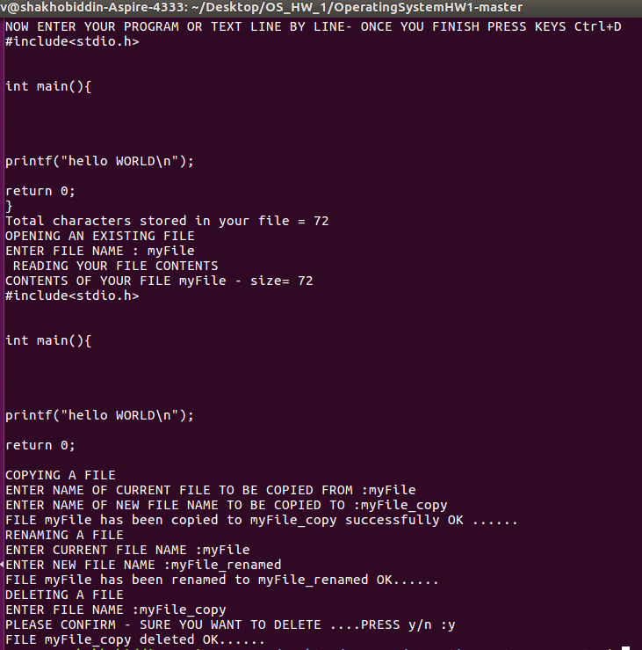

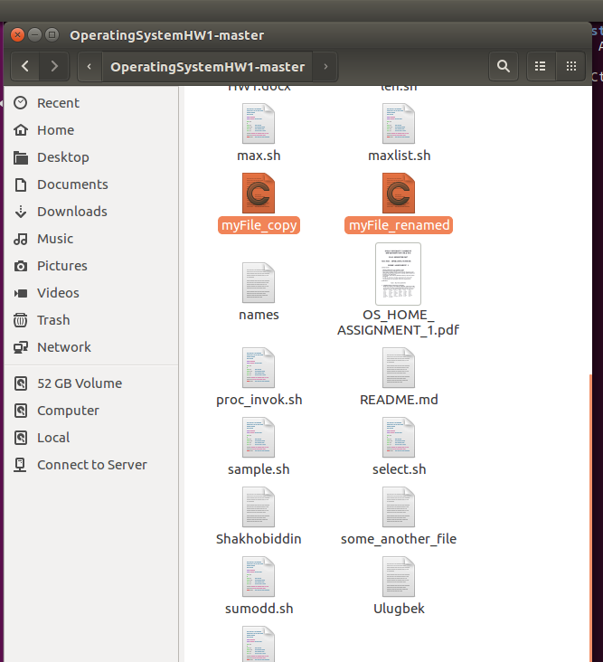

These two screenshots above are to demonstrate how the C program went on working.

**1C.**

a) Sample shell script. This script asks you your name, and as you press enter it shows you info about your home dir, hard disk free space and others, which are provided in the screenshot below.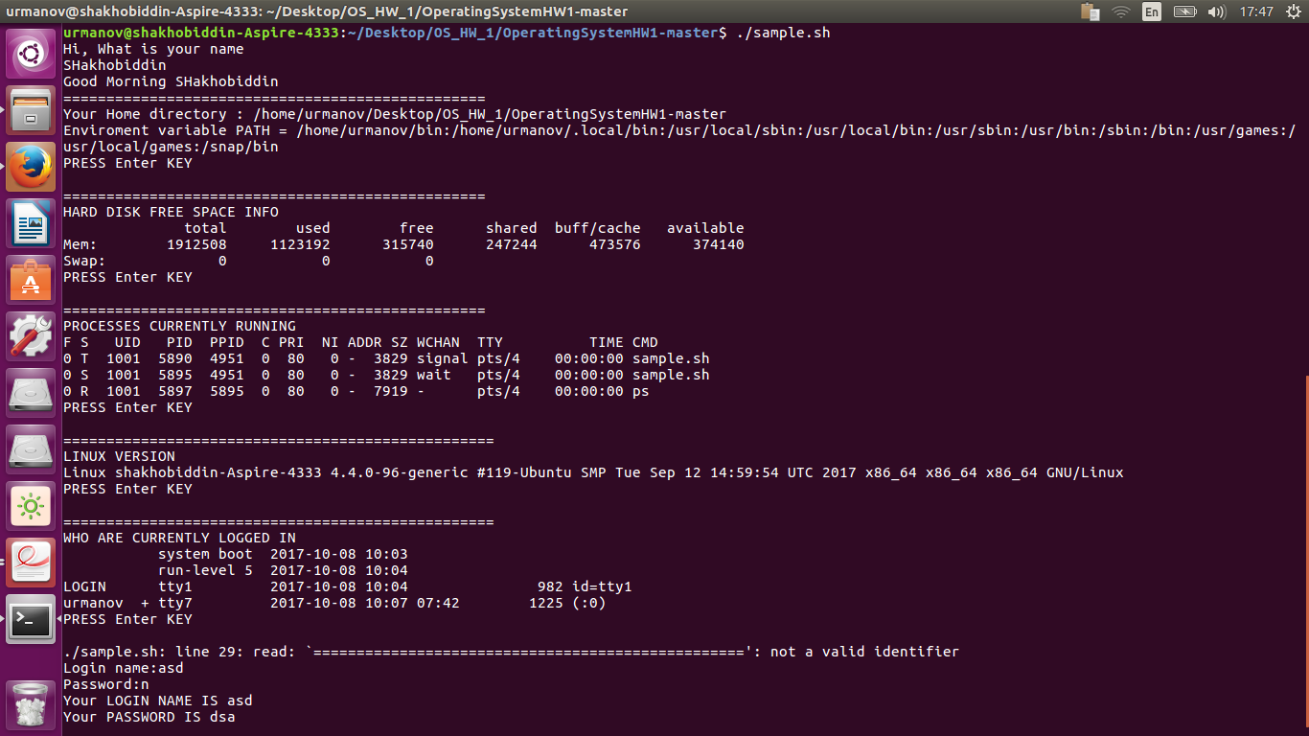

b) File-Line, word and byte count

This script counts you number of characters, words and lines in the file that you specified.

wc -l $FNAME - counts #of lines

wc -w $FNAME - counts #of words

wc -c $FNAME - counts #of bytes

The screenshot below is showing how the script went on.

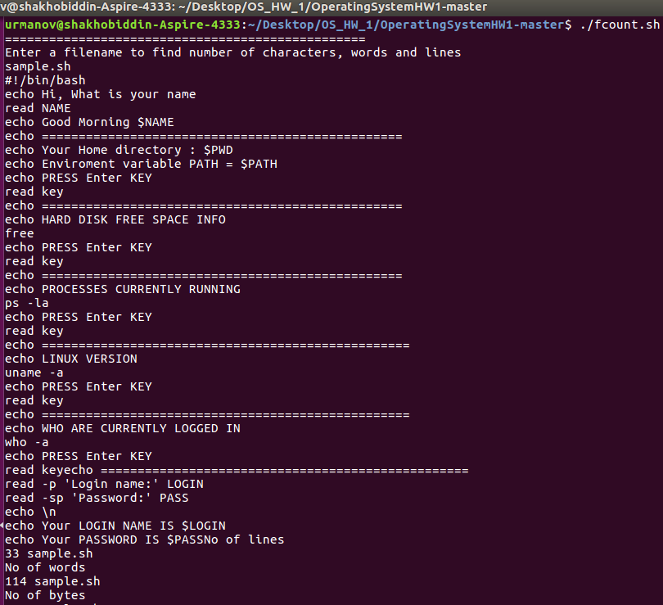

______________________________________________________________________

c) File Sorting

This script asks you enter file name and 10 names which will be stored in this file. And the entered names are sorted in both orders(asc and desc).

Keyword used to sort is: sort, sort -r for reverse order.

The screenshot below is showing how the script went on.

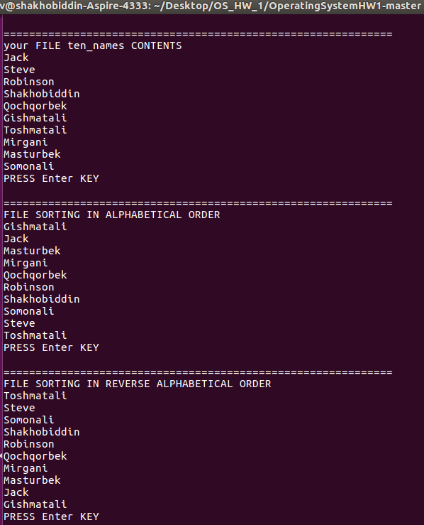_

_____________________________________________________________________

d) Examples for Conditional construct if ...then....else ...fi.

This script gets from user the value of LONG and using the

syntax: if [$LONG -eq 1], which means "if LONG is equal to 1" branches into two cases ls-la or ls, which show extended and short directory listing.

The screenshot below is showing how the script went on.

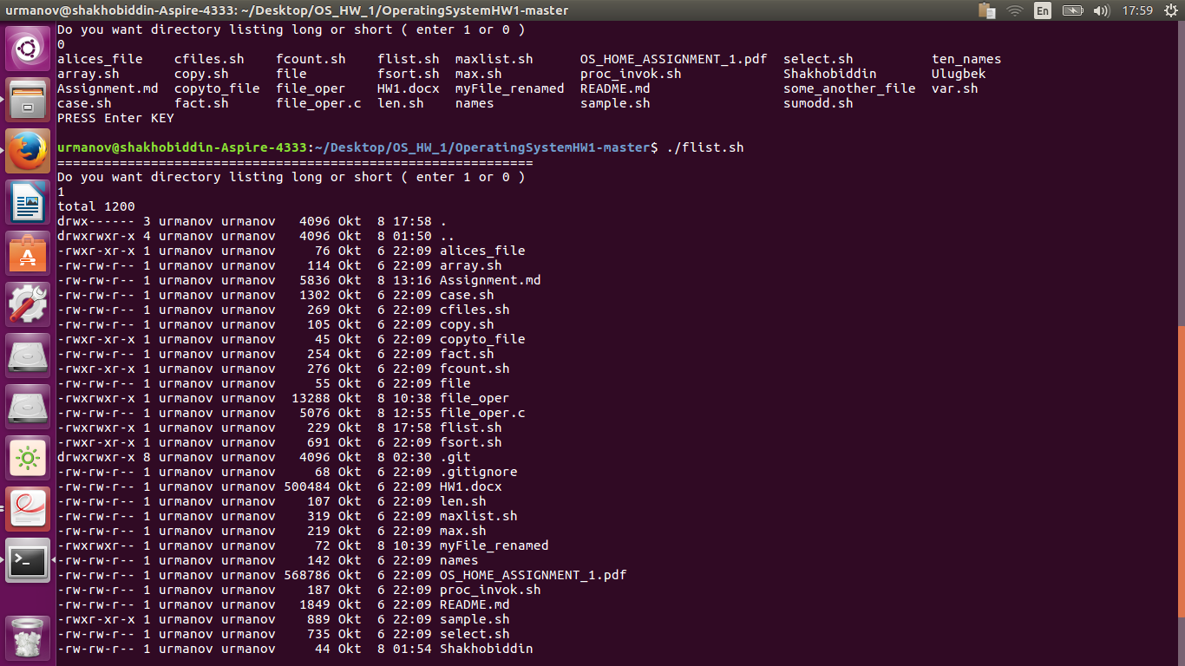

______________________________________________________________________

e) i) while do ..... done construct

The script shows how while-do-done loop structure works, calculating the sum of the first odd integers. Variable A here serves as an iterator for checking the limit, B and C are used to calculate the sum. And the sum is stored in variable B.

The screenshot below is showing how the script went on.

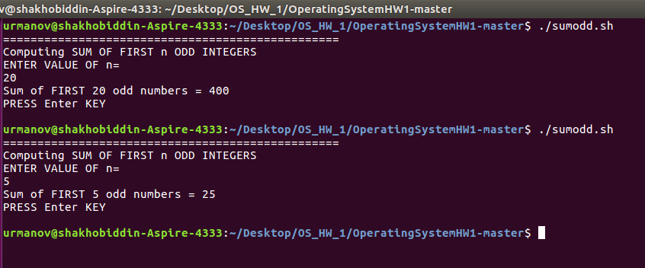

______________________________________________________________________

ii) for do .....done construct

There are two scripts here, the first script shows how for-do-done loop structure works with the example of finding the files with the extenion .c.

And the next script(sum100.sh) computes the sum of first 100 integers using for-do-done structure.

The screenshots below are showing how the scripts went on.

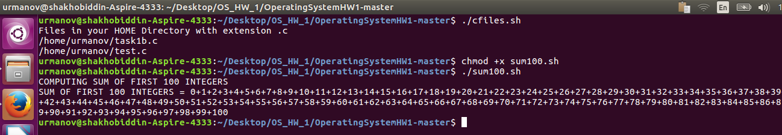

______________________________________________________________________

iii) until do..... done construct

The script shows how the until-do-done loop structure works, computing the factorial of the entered value n.The screenshot below is showing how the script went on.

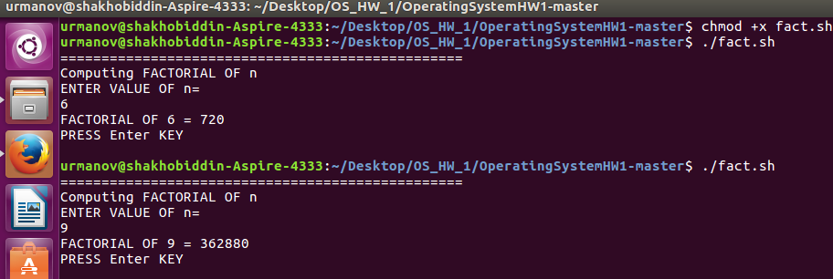

______________________________________________________________________

f) Example for Multi-way Branch - case .....esac

The script shows how to use Multi-way branching case...esac. The program provides you with 11 choice menu for dealing with flies or giving some info(linux version, etc).

Branches are finished with double-semicolons(;;) which means the end of the branch.

And in the last choice most interesting there is *) case which means default case(any other value which is not specfified above).

case is finished with esac.

The screenshots below are showing how the script went on.

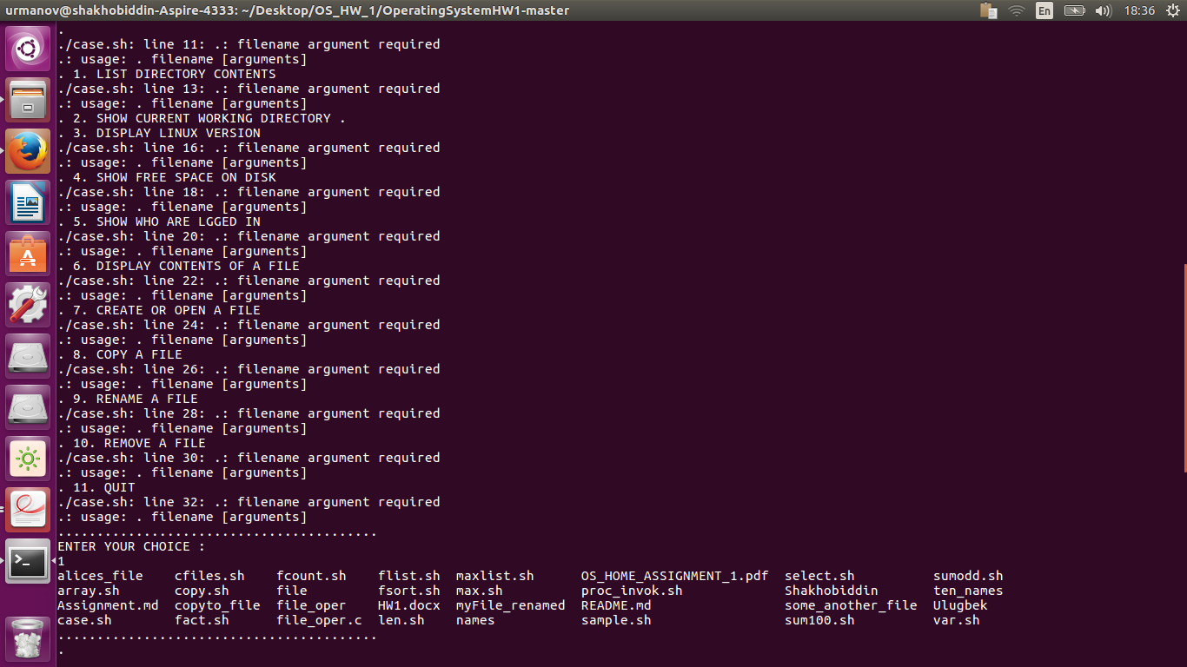

______________________________________________________________________

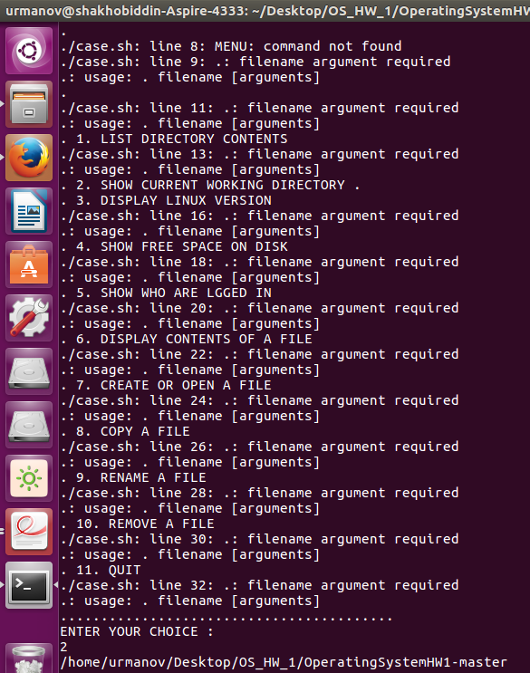

g) Example for Select do ....done and if ...elif ....fi constructs.

The script shows how to use select-do-done and if-elif structres. In the string variable OPTIONS the options are specified, So that "select choice in $options" provides you menu. if-elif structure is used to find the selected option and execute proper commands.

The screenshot below is showing how the script went on.

Here should be part1_C_g_1.png, part1_C_g_2.png. part1_C_g_3.png.

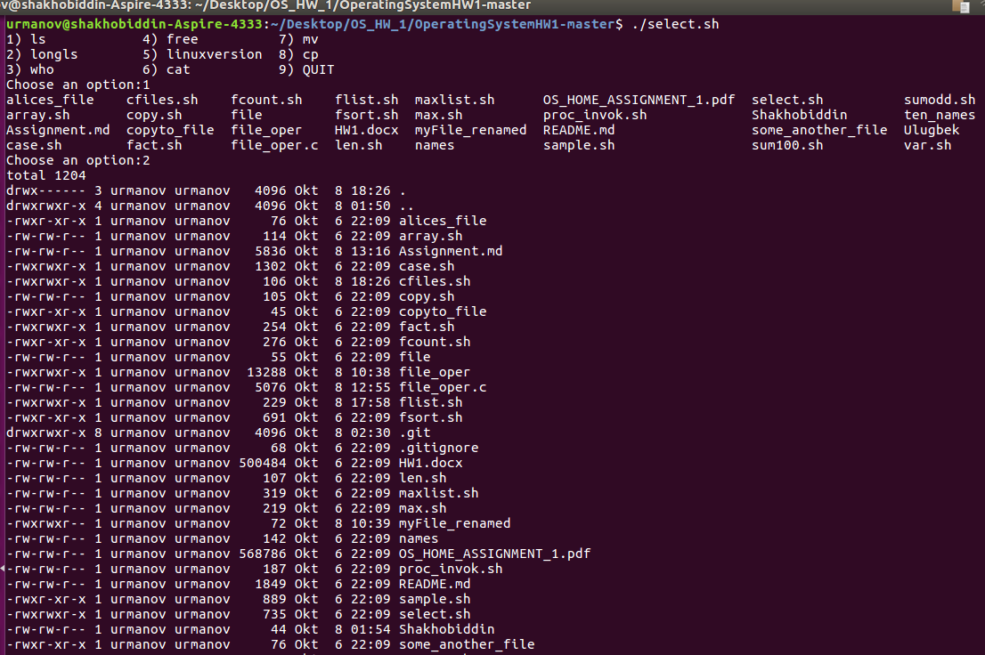

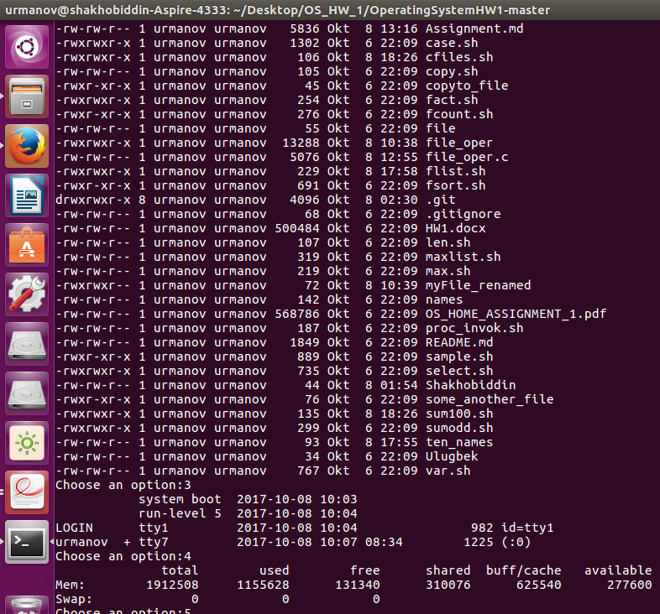

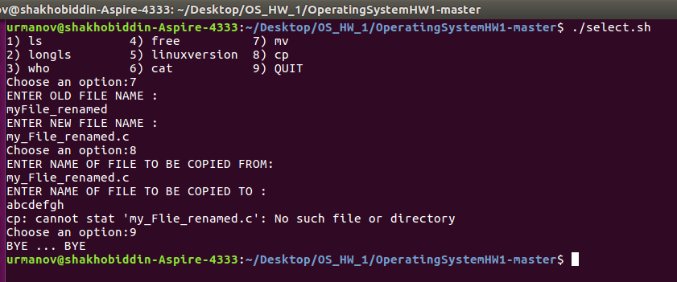h) Passing parameters using Command Line Arguments

The scipt demonstrates the use of command line argguments. $1 is for getting the first command line argument, and $2 is for second. THe program gets $1 and $2 as the names of the files, where the content of the file1 should be copied to file2.

The screenshot below is showing how the script went on.

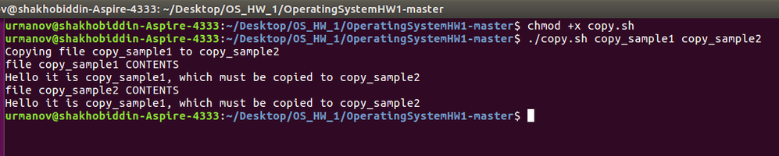______________________________________________________________________

i) Length of a string

The script reads the string and gives the length of the string as output. ${#STR} is used to show the length of the string.

The screenshot below is showing how the script went on.

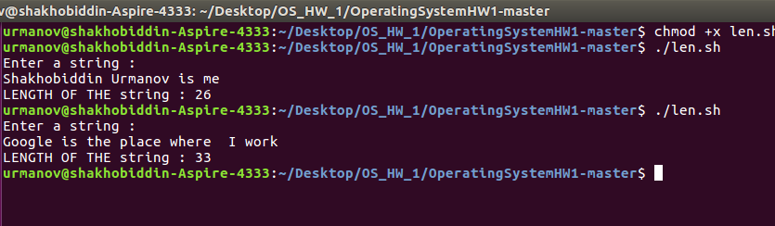______________________________________________________________________

j) Use of Special Variables

The script shows the use of special variables.

$0 - contains the name of the running script

$# - contains # of command line arguments

$@ - contains All the arguments supplied to the bash script

$? - contains The exit status of the most recently run process

$$ - contains The process ID of the current script

$USER - contains User Name of the user running the script

$HOSTNAME- contains The hostname of the machine the script is running on

$SECONDS- contains The number of seconds since the script was started

$LINENO - contains Current line number in the Bash script

$RANDOM - contains Random number returned by the RANDOM variable

The screenshot below is showing how the script went on.

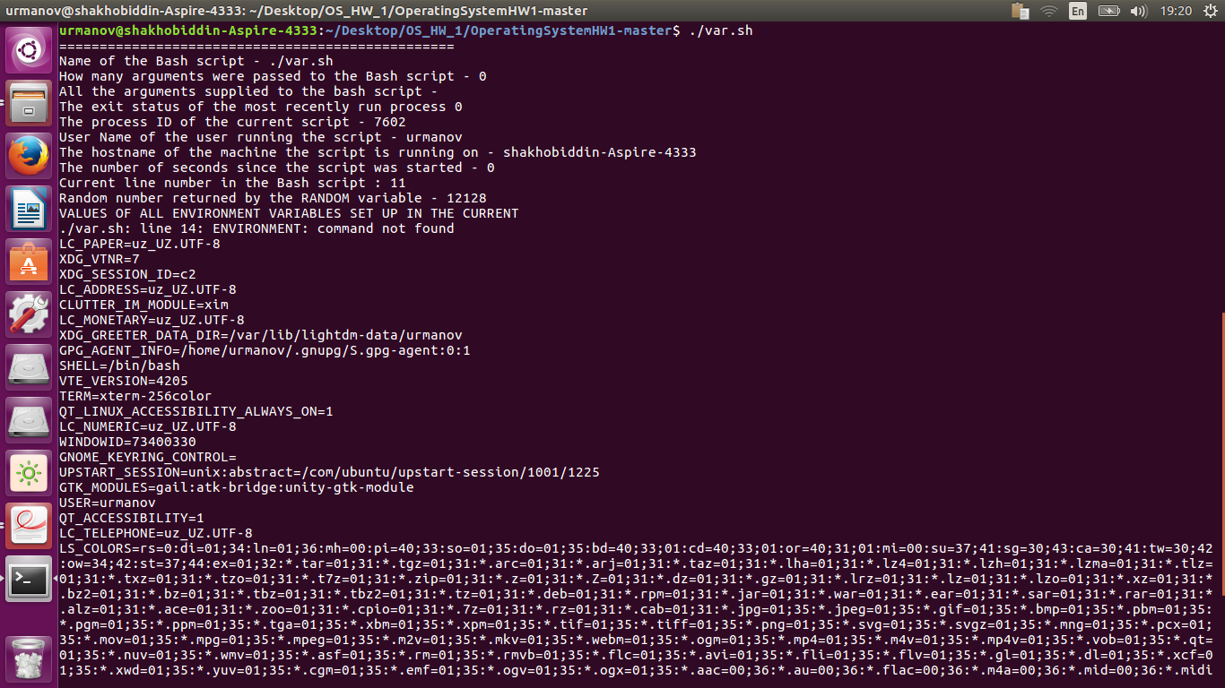______________________________________________________________________

k) Using Arrays

i) In this script we can see the declaration format of the array - name=(1 2 3 4). And each element of the array is referenced like this - ${list[$I]}.

and the array is printed out using the while loop.

ii) This is the next example of using arrays. Here the maximum element is found in the given array.

iii) In this script array of the size of n is created and n values are taken from input. And in this array the maximum element is found and echoed into screen.

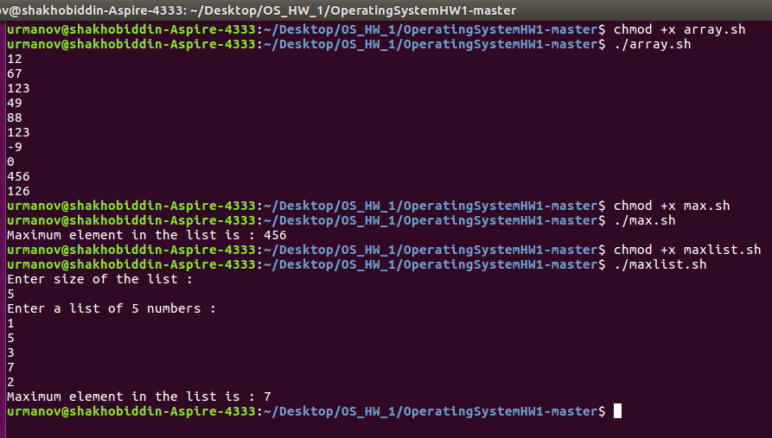

l) Procedure Invocation

The scipt shows how the procedures are invocated and how variables are passed into them. $? this expands the exit status of the most recently executed command

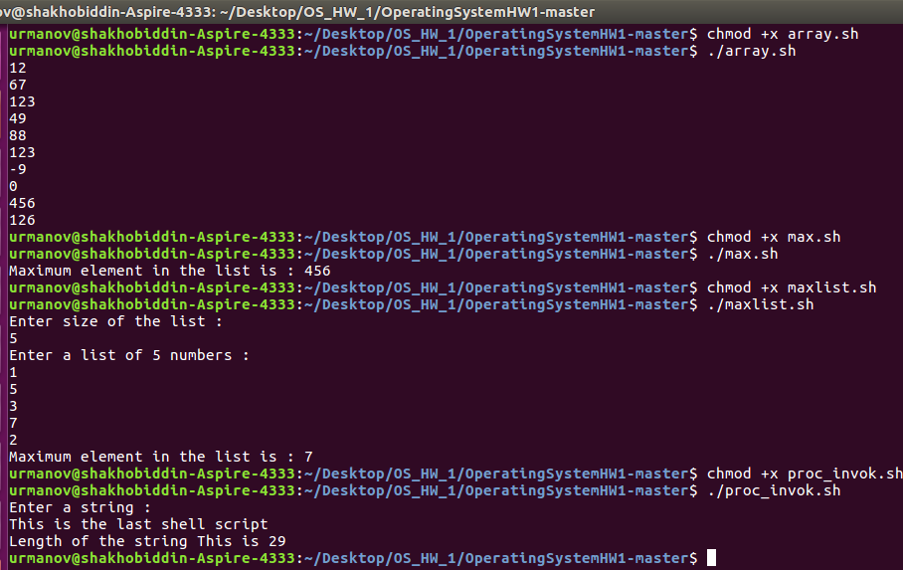

**Part 2: Activities**

**2A**

1. PS1 (Prompt String 1) is one of the prompts available in Linux/Unix. When you try to login to any machine, you have to enter user name and password. Once you are done with this you are presented with some info like who logged in, on what machine he logged in, what is his present working directory and if the logged in user is a super user or a normal user. This is done by using PS1 prompt which is a [inbuilt shell variable](http://www.linuxnix.com/2011/08/linux-shell-inbuild-variables-system-admin.html).

d- the date in “Weekday Month Date” format

t- current time in 24 hour HH:MM:SS format

u – username of current user

# - the command number of this command

@ - the current time in 12 hour am/pm

$ if the effective UID is 0, a #, otherwise a $

\ - a backslash

h – host name up to the first

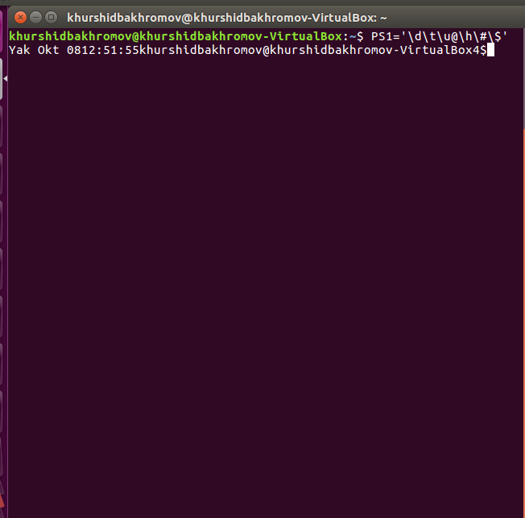

1. This command shows all files and folders with their date of creation in decreasing order

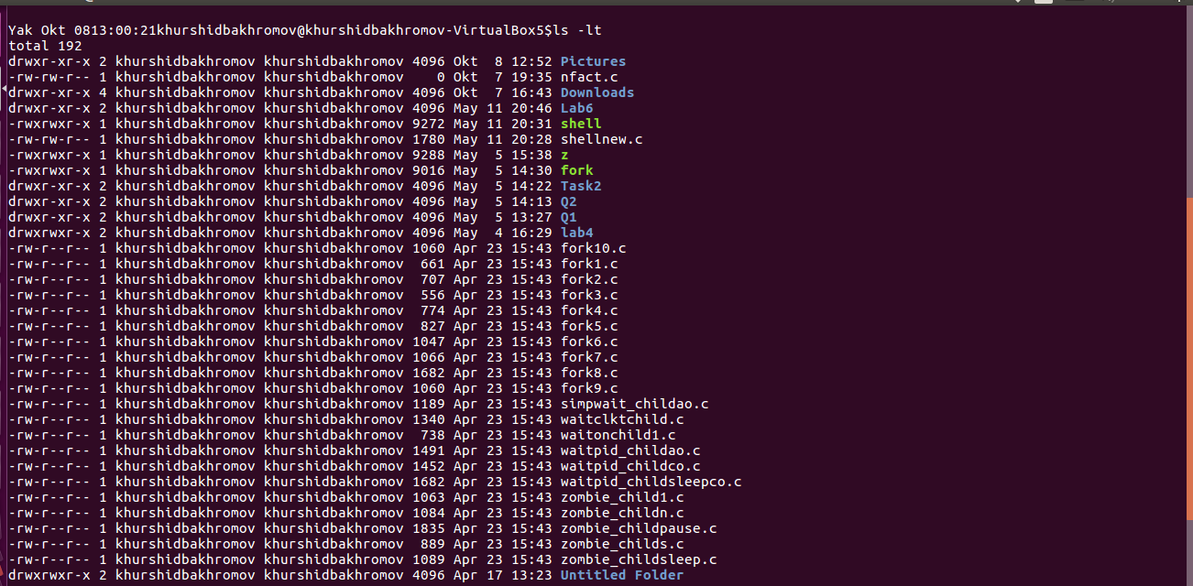

This command shows all files and folders with their date of creating in increasing order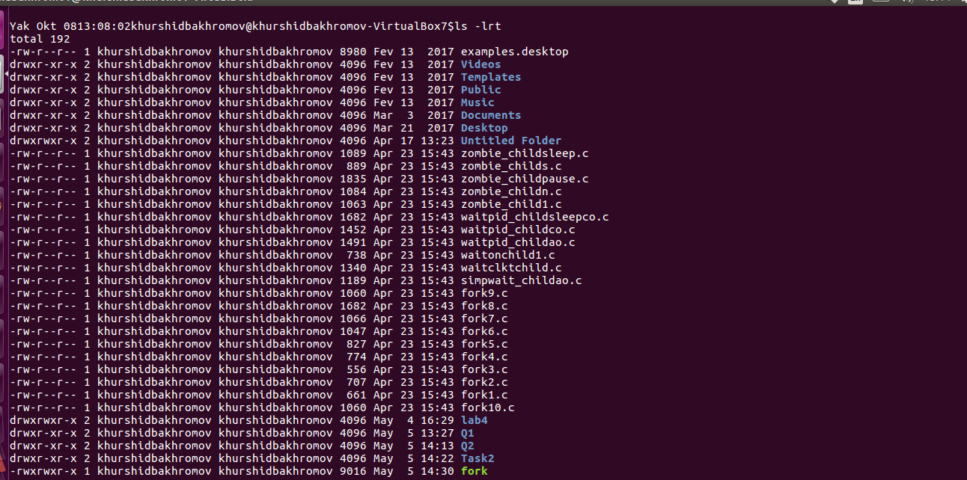

1. List information about the FILES (the current directory by default).

Shows list of commands with ls

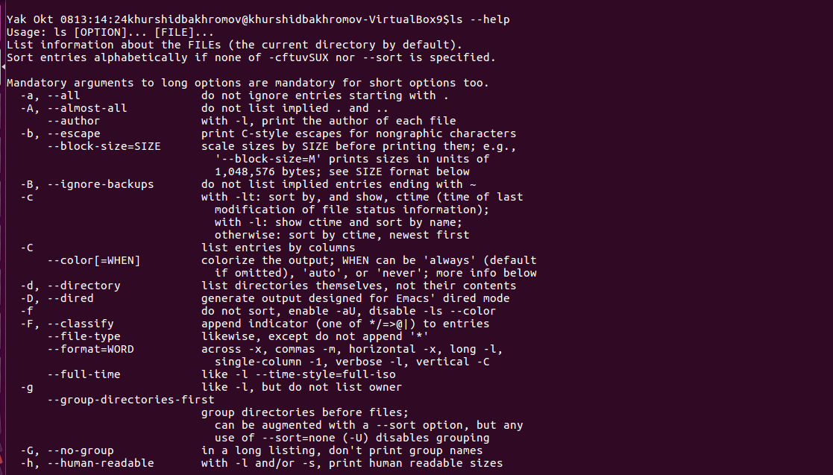

1. This command increase ID of user. See picture…….

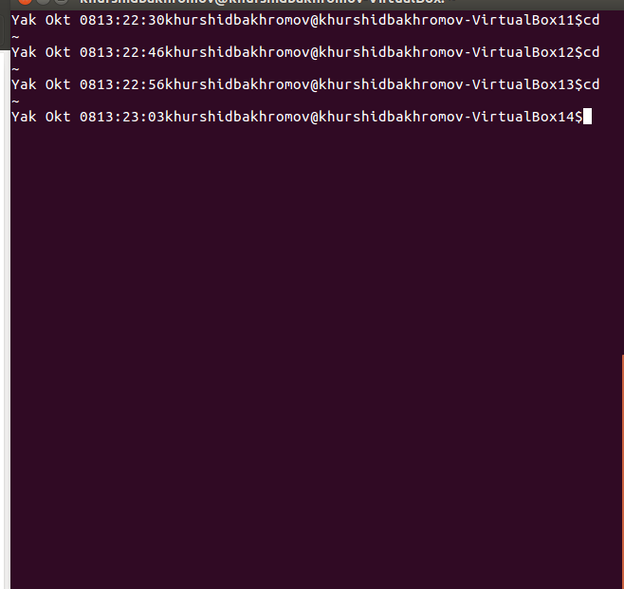

1. This command helps us connect files. In this case connect to computer’s information.

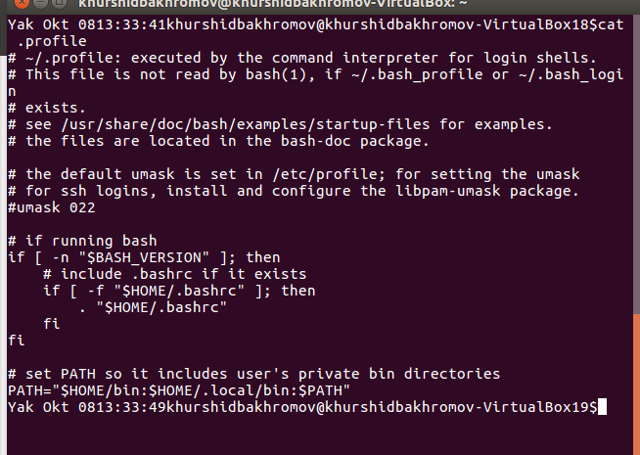

1. Print system information. uname –r print kernel release

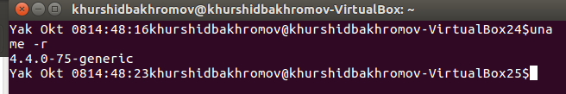

1. Print system information. uname –a print all information, in the following order, except omit –p and –I if unknown

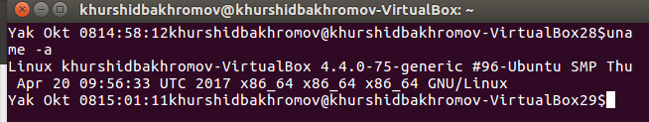

1. Print system information. uname –n print the network node hostname

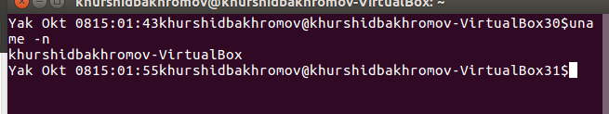

1. Print system information. uname –o print the operating system

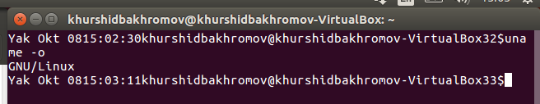

1. Print system information. uname –p print the processor type

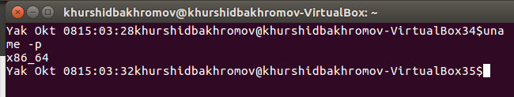

1. This command prints processor type

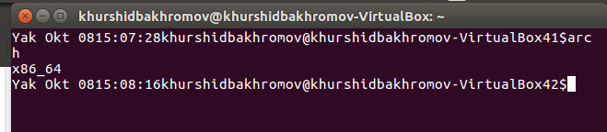

1. Change file timestamps

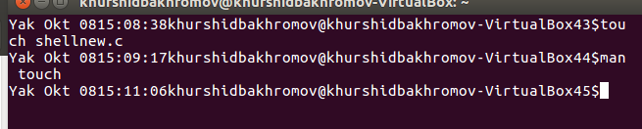

1. List directory contents use a long listing format

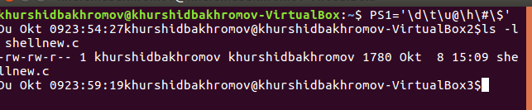

1. This command changes the file mode bits of each given file according to mode, which can be either a symbolic representation of changes to make, or an octal number representing the bit pattern for the new mode bits.

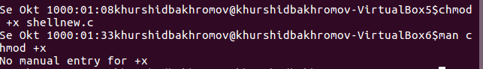

1. List directory contents use a long listing format

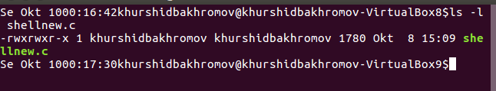

1. This command concatenate files and print on the standard output.

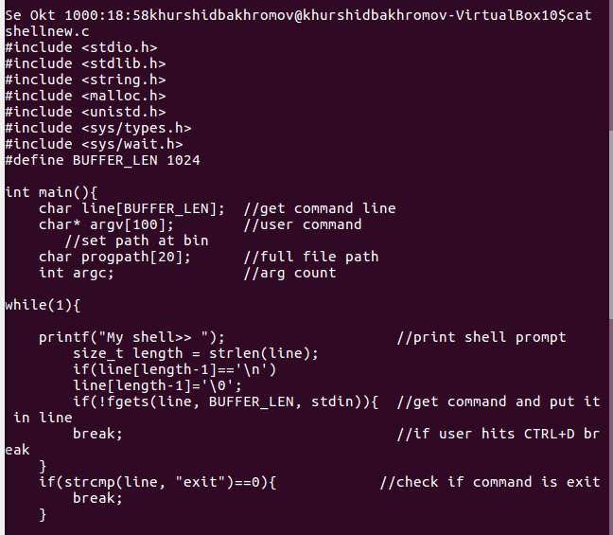

GNU History Library. Many programs read input from the user a line at a time. The GNU History library is able to keep track of those lines, associate arbitrary data with each line, and utilize information from previous lines in composing new ones.

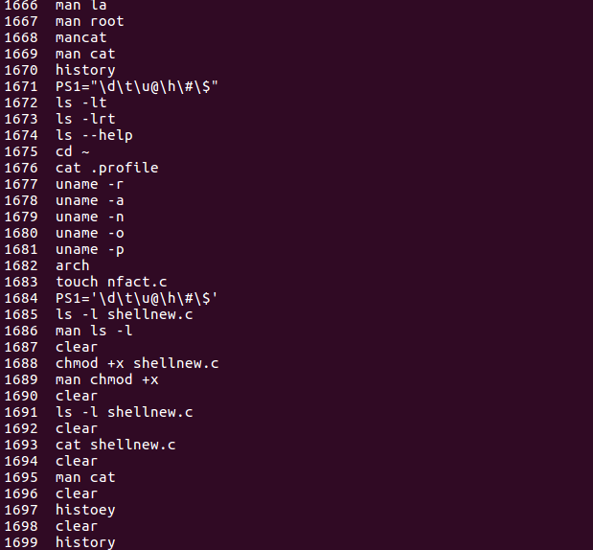

1. Takes last 25 written inputs by user

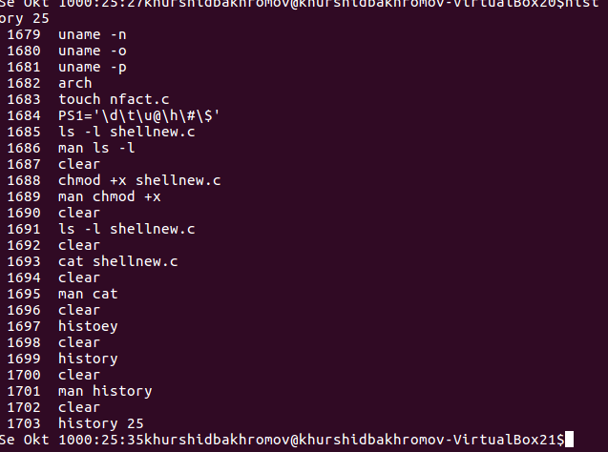

1. This command report file system disk space usage. Show information about the file system on which each FILE resides, or all file systems by default/

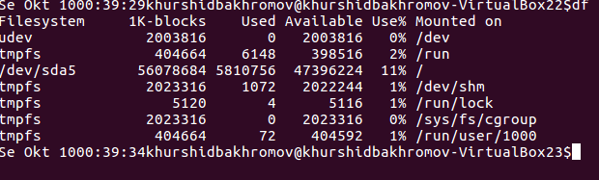

This command report file system disk space usage. Show information about the file system on which each FILE resides, or all file systems by default. Print sizes in powers of 1024

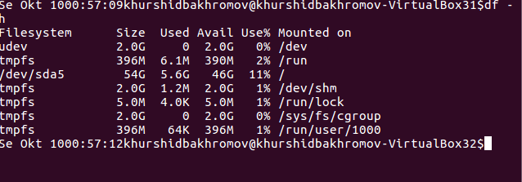

1. This command display Linux processes

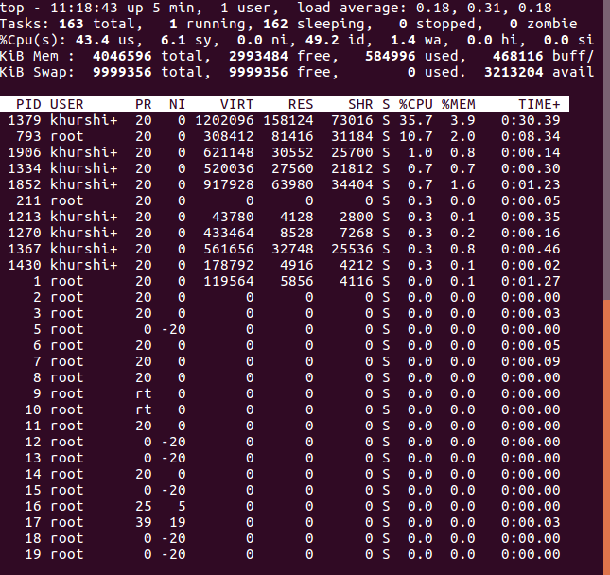

1. This command report a snapshot of the current processes.

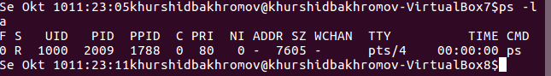

1. This command report a snapshot of all processes

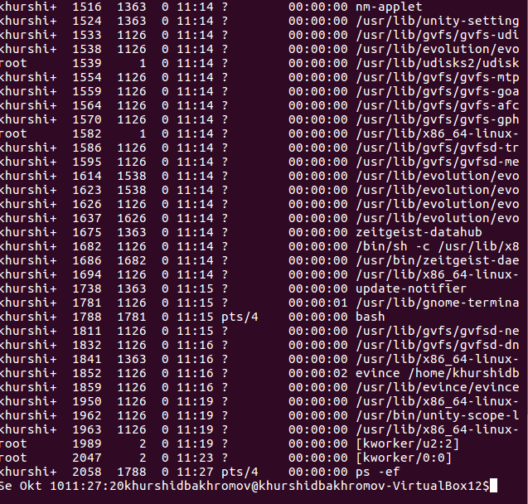

1. This command report a snapshot of all processes ordered by time

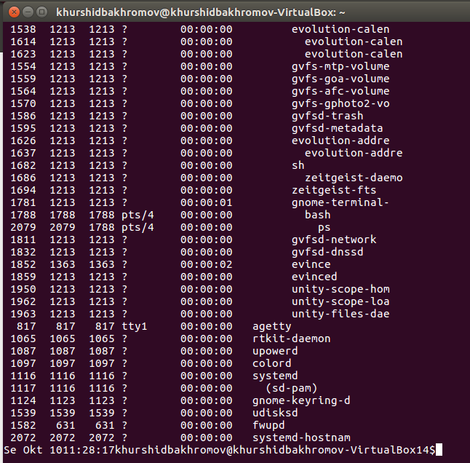

1. This command shows all information about cpu. Address size, power management, cupid level and so on.

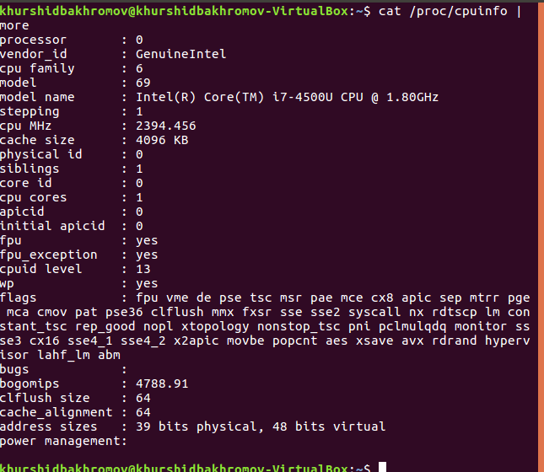

1. This command shows all information about cpu. Address size, power management, cupid level and so on.

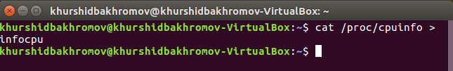

1. This command shows characteristic of CPU. Processor, number of cores, model name, frequency and cache size.

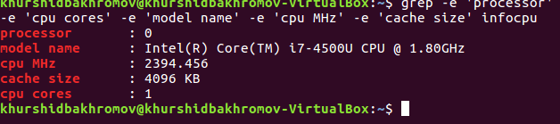

1. This command shows number of Processor

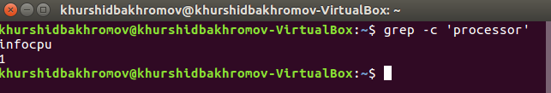

1. This command shows number of core in processor

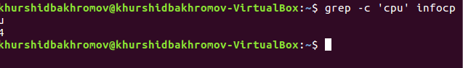

1. This command open list of file.

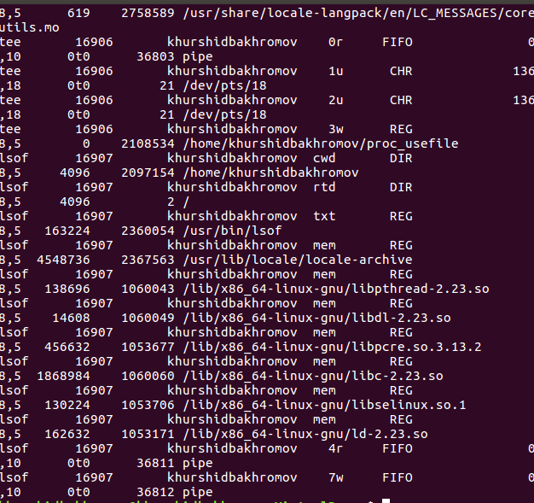

1. This command show number of processor

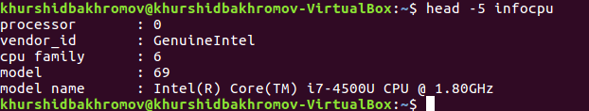

1. This command shows all information about processor

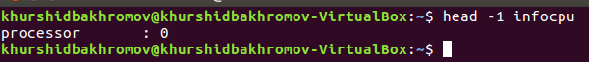

1. This command puts head position to tail



1. This command gives last information or sentence of processor

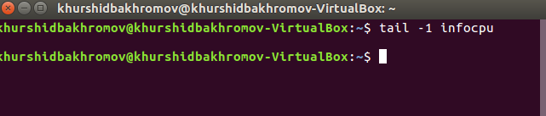

1. This command gives last 5 information about cpu

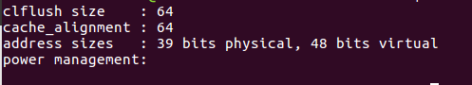

1. This command puts last information to core4info

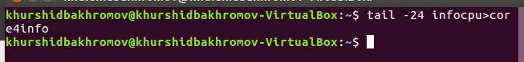

1. This command shows information put in last example 37 into core4info

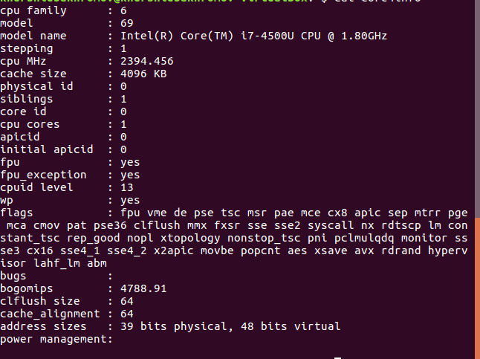

1. This command shows information from core4info last 5 and previous information

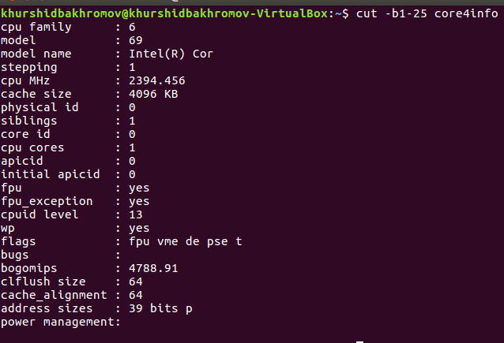

1. This command shows information about core number 0. Shows what kind of processes is going what flags is used

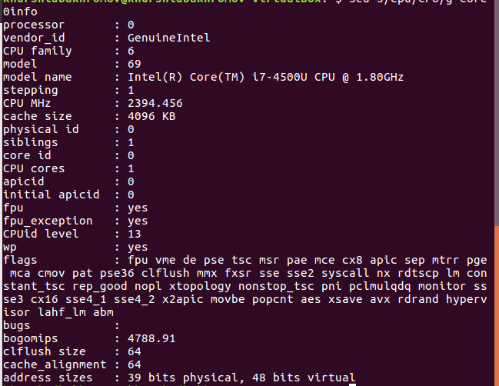

1. This command shows all user files in alphabetical order

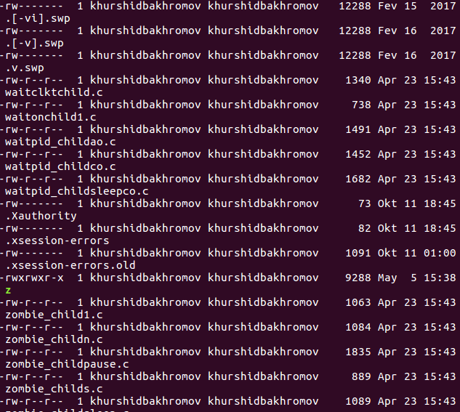

1. This command shows info about listdir

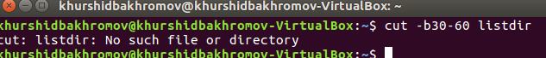

1. This command shows last 10 command typed by user in cmd

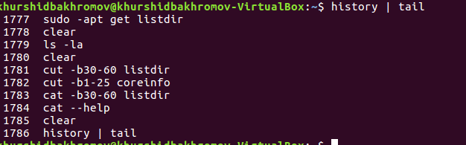

1. Tell how long system in running



1. Estimate file space usage

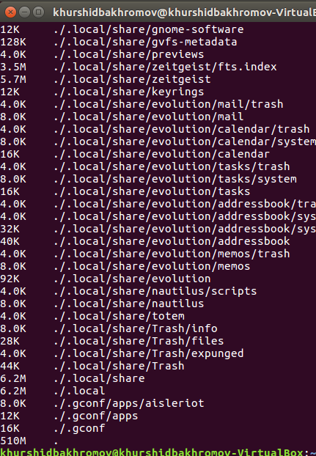

1. This command show space used.



1. This command shows size of files in increasing order

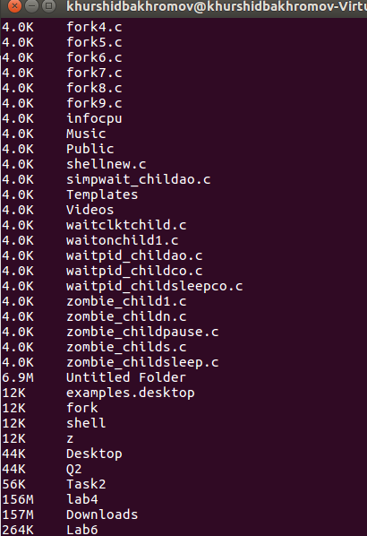

1. This command shows size of files in decreasing order

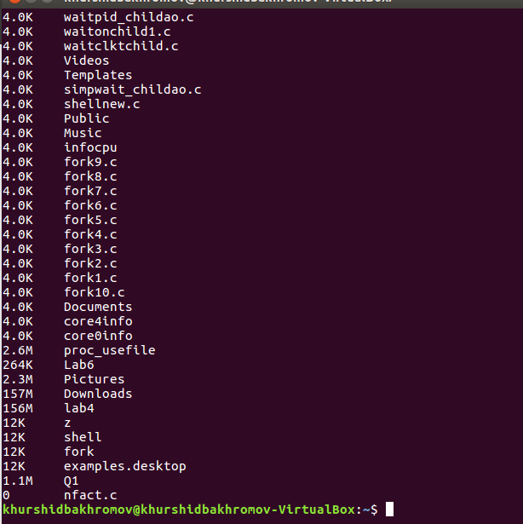

1. This command compress or expand files



1. This command shows all information about files in root directory

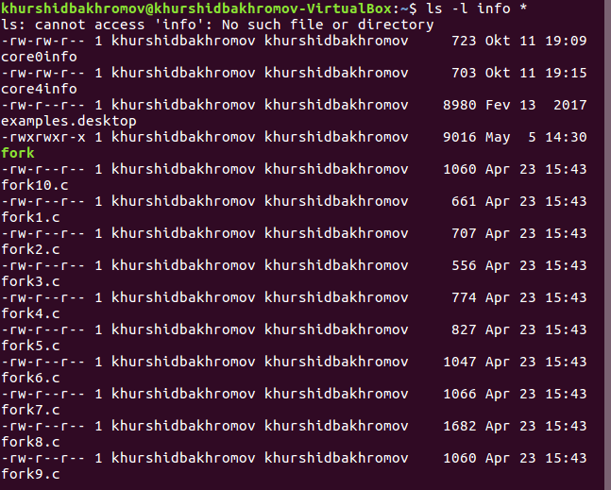

1. This command compress or expand files



1. This command shows all information about files in root directory

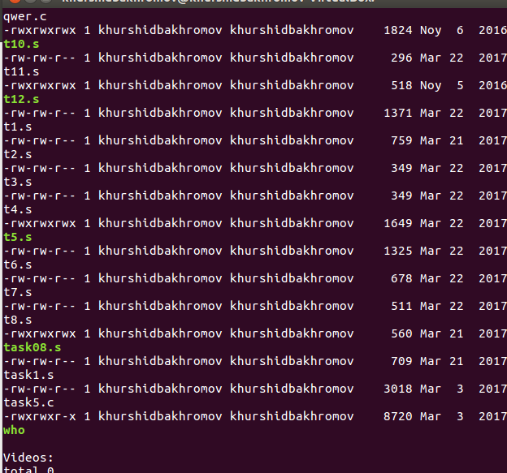

1. Create a compressed file where put cpu information



1. This command shows detailed information of all files

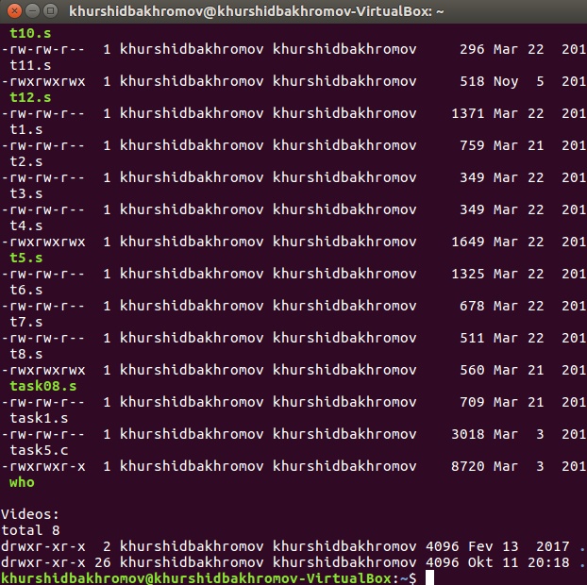

1. Create a zip file with cpu information



1. Show cpu information

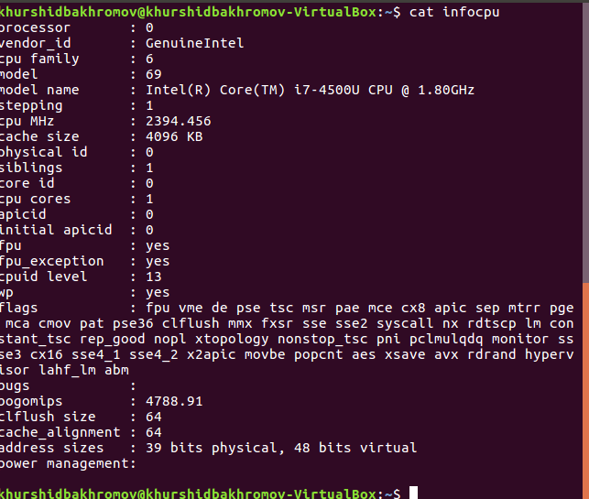

1. Show information stored in cache

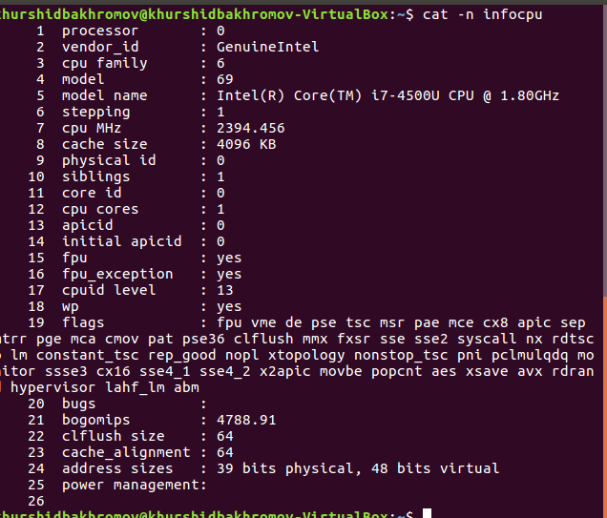

1. This command show info of processor

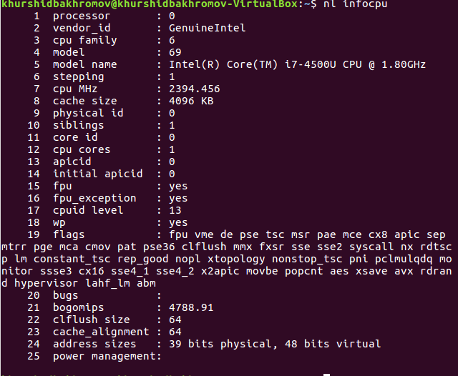

1. This command convert text files for printing.

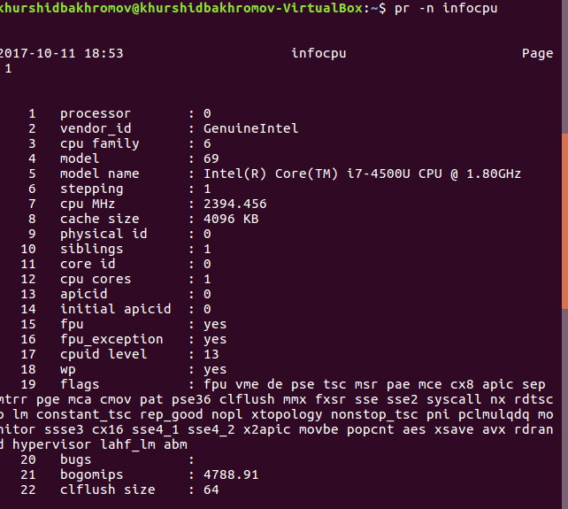

1. This command print lines matching pattern

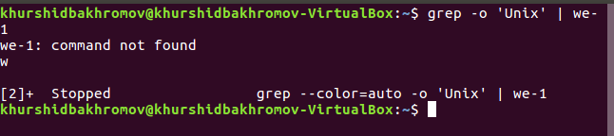

1. This command report file system space usage. Limit like listing to local file systems

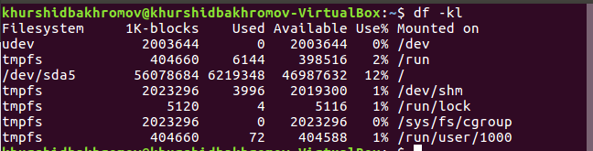

1. This command report file system space usage. Print sizes in powers of 1024

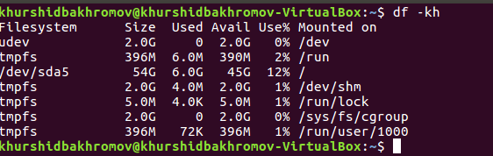

1. This command show path from home directory

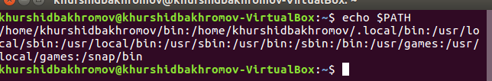

1. This command saves value to a %rax register



1. This command print saved value from a

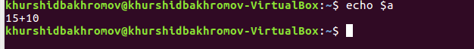

1. This command saves value 75 to b



1. This command print value of b which was saved in previous example



1. This command saves sum of values from a and b to c



1. This command print sum of values 75+15+10 which is 100



1. In this case sum of two values saved in D



1. Shows sum of values



1. Shows path to home directory



1. This command search for file named linux in repository



1. This command make ls as list



1. Shows all file in home folder

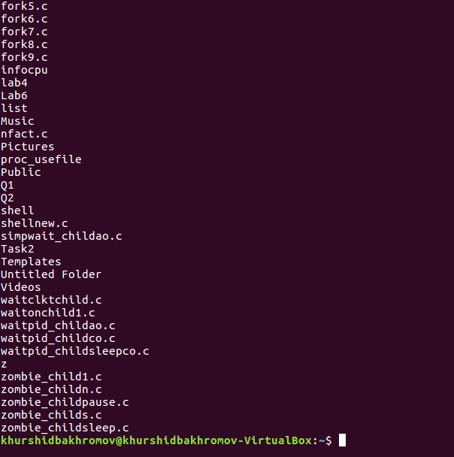

|  |  |
| --- | --- |
| 1. 75. This command reverse line characterwise   2A | 1. 76. Shows all file in home folder   2A |

1. This command reverse whole sentence



1. Make links between lines



1. Use a long listing format

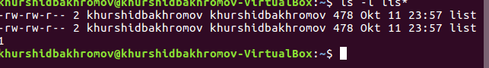

1. This command make symbolic links instead of hard links

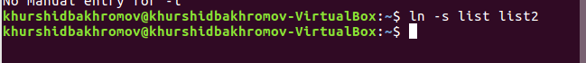

1. Change name of shell username



1. This command shows all lists

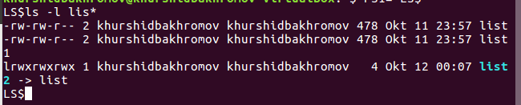

1. This command search list which start with word l

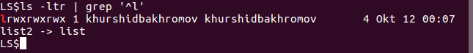

|  |  |
| --- | --- |
| 1. 84. Print all files from list1   2A | 1. 85. Print all files from list1   2A |

1. Determines list type

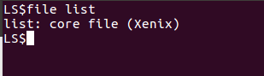

1. Determines list type

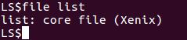

1. Determine list type which is symbolic relation



1. Determine file type which is directory

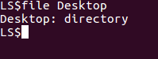

**2A.90.png**

91) gives all files in current directory with extension .o and its information

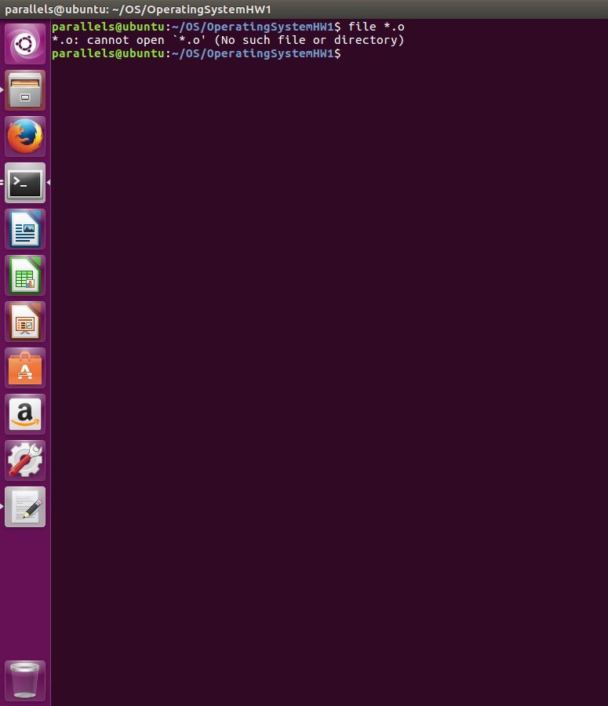

92) gives all files current directory with extension .c and its information

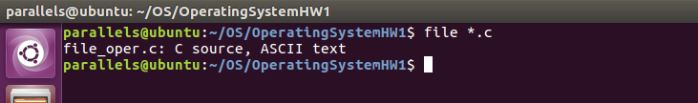

93) gives all files current directory with extension .sh and its information

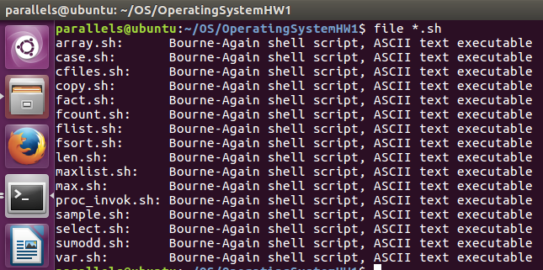

94) gives all files in current directory with its information

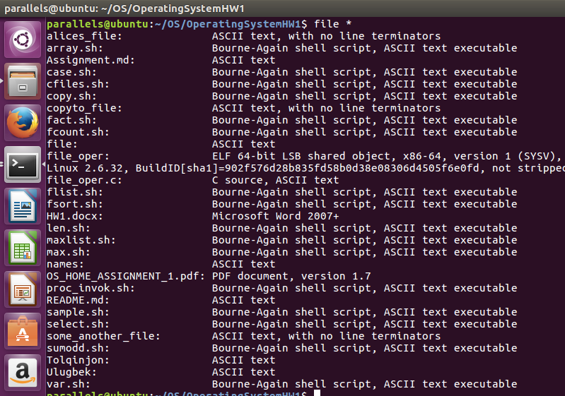

95) show content of given file

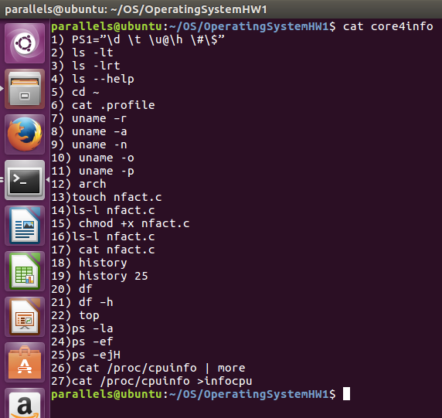

96) first takes 14 lines from begginning as content and shows 1 line from the end of taken content from file

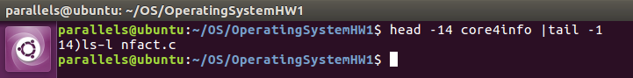

97) delete 1st row from core4info, -i means insertion

98) shows content of core4info

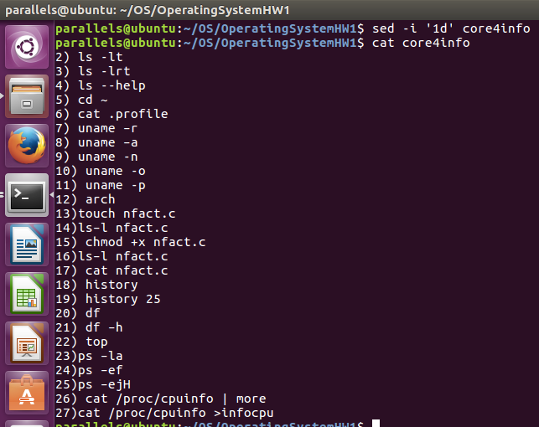

99) delete the last row from core4info file

100) shows content of core4info file

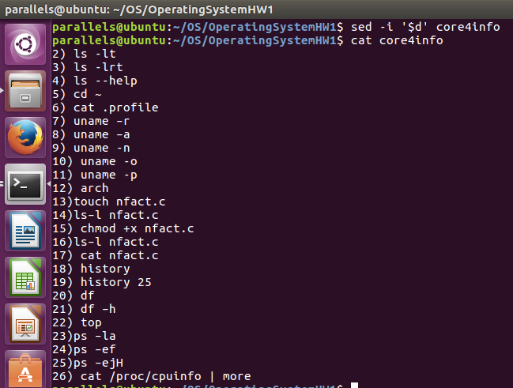

101) prints 13 line of core4info

102) prins byte count in 13th line

103) prints word count in 13th line

104) prints revese version of 13th line

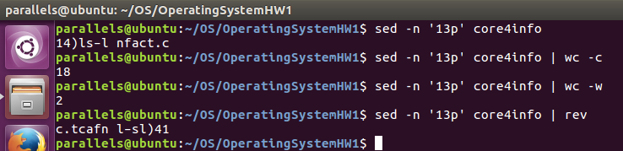

105) prints from 13th to 18th the line

106) prints new line counts from 13th to 18the line

107) prints word count from 13th line to 18th line

108) prints byte count fro 13th line to 18th line

109) prints the last row of the core4info file

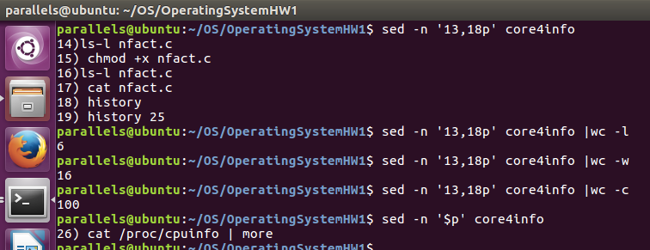

110) the first it takes revese string, then split by delimeter and takes the first word, then prints revese version of this word

111) the first it splits string by the delitmeter and prints the 4th element taken array

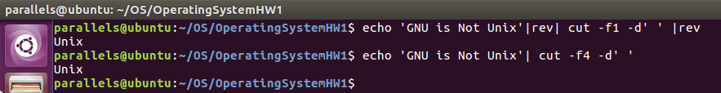

112) prints 4th element from every row

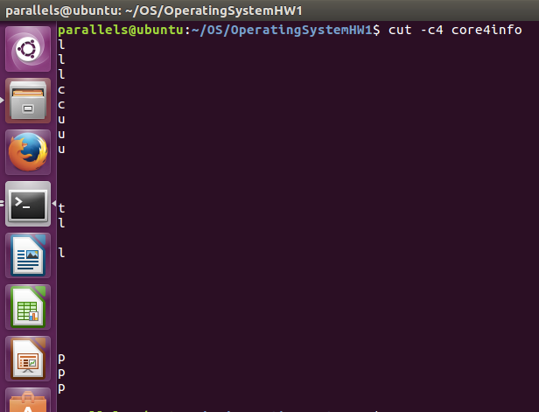

113) prints 4th and 6th elements from every row

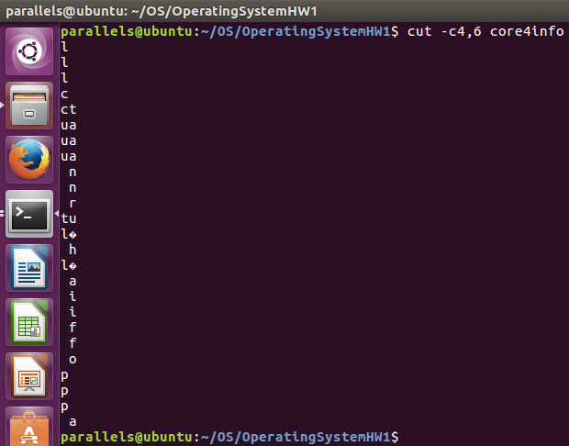

114) prints from 1st to 7th element in every row

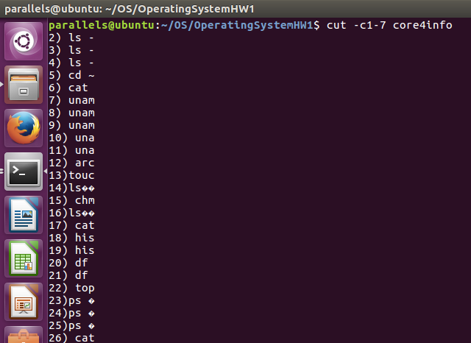

115) prints from beginning till 6th element from every row

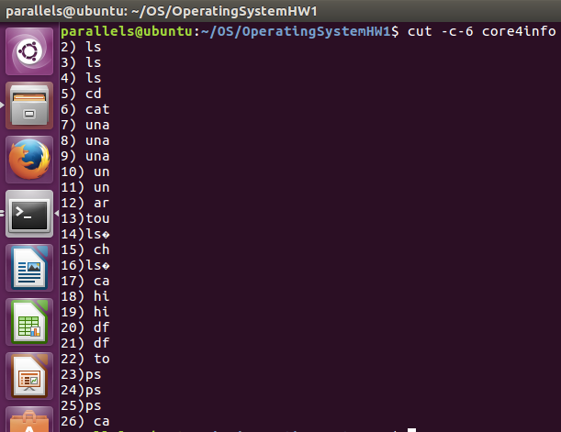

116) prints from 10th till end of every row

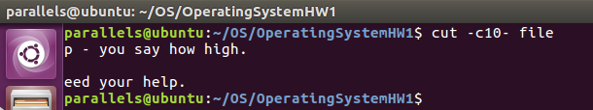

117) ~~~it gives error~~~

118) prints 2nd element of array which is taken from splitting by delimeter from each row(new line)

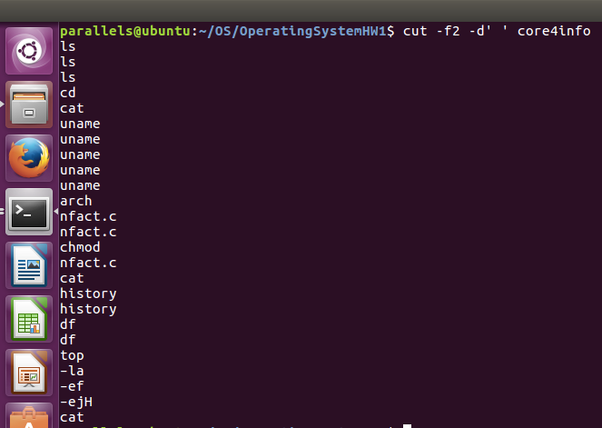

119) prints from 1st till 2nd element of an array which is taken from splitting by delimeter from each row

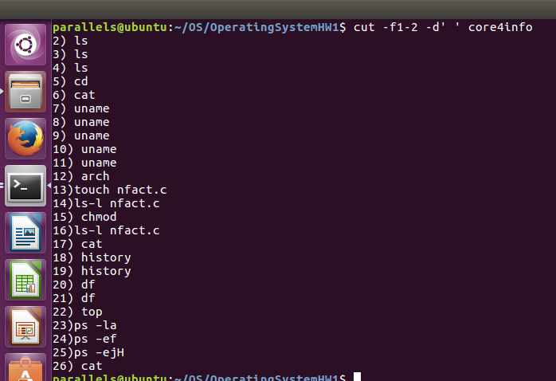

120) the same as 118

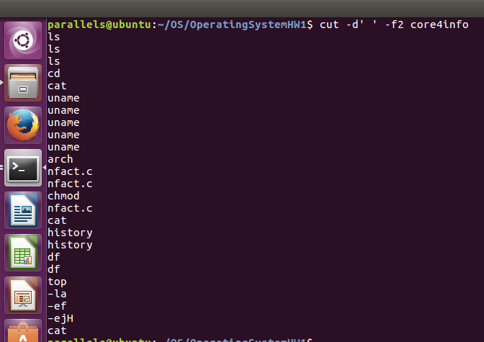

121) prints 2nd and 3rd element of an array which is taken by splitting by delimeter from each row

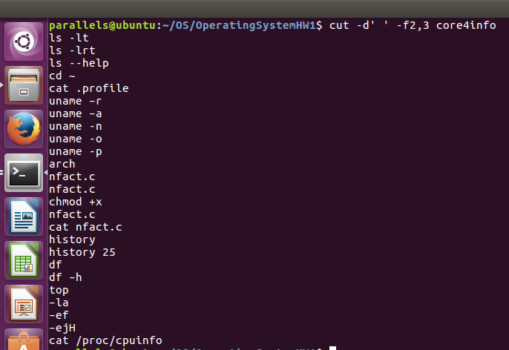

122) prints from 1st till 3rd element of an array which is taken by splitting by delimeter from each row

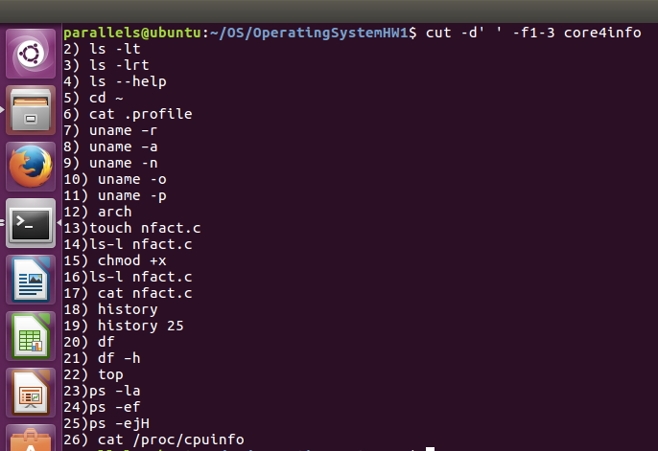

123) prints from beginnging till 3rd element of an array which is taken by splitting by delimeter from each row

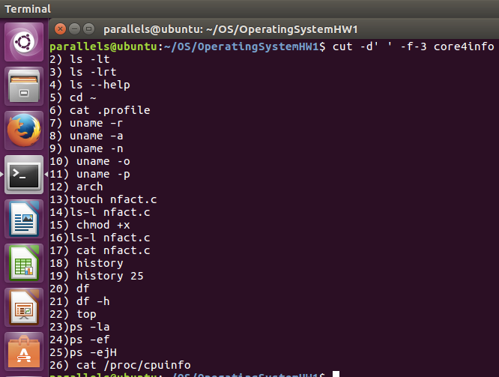

124) prints from 2nd till end of an array which is taken by splitting by delimeter from each row

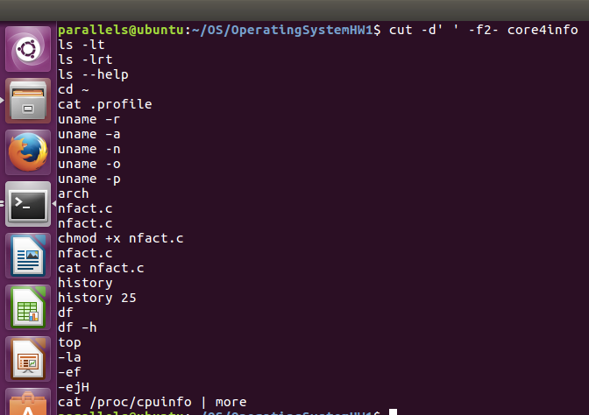

125) prints 1st element of an array which is splitted by delimeter ':' of every row

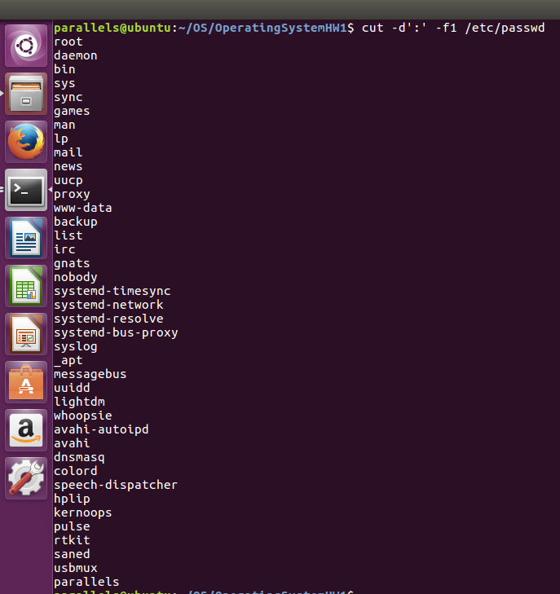

126) prints 2nd and 3rd element of an array which is splitted by delimeter of every row, putting delimeter di separate elements

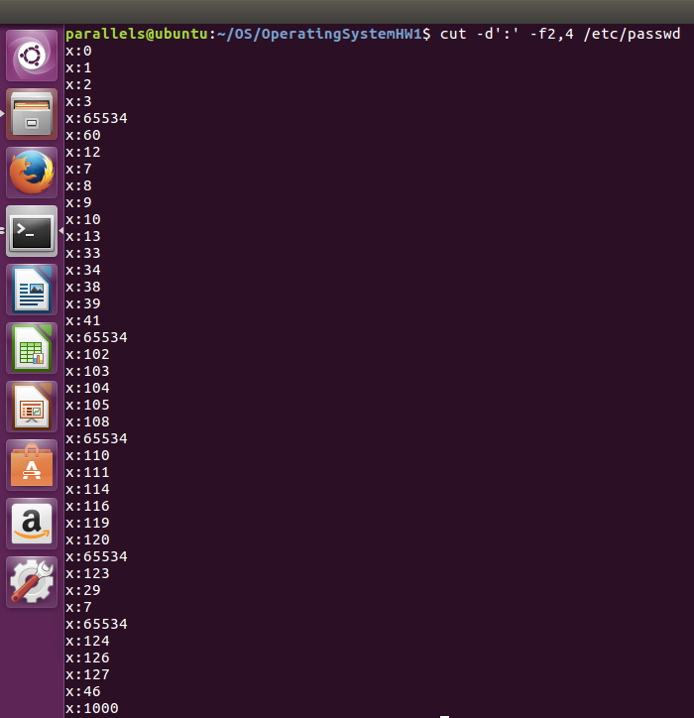

127) copy file /etc/passwd to current directory with filename as password

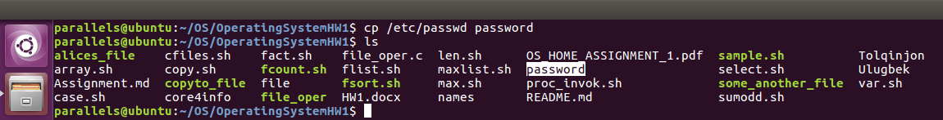

128) prints content of password file

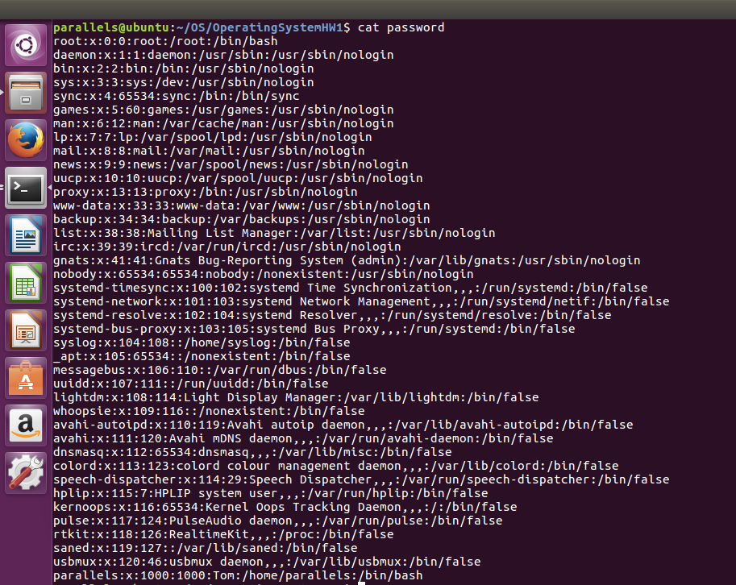

129) should print 1st element of an array splitting by delimeter, but as there is no delimenter ' ', it prints the whole content

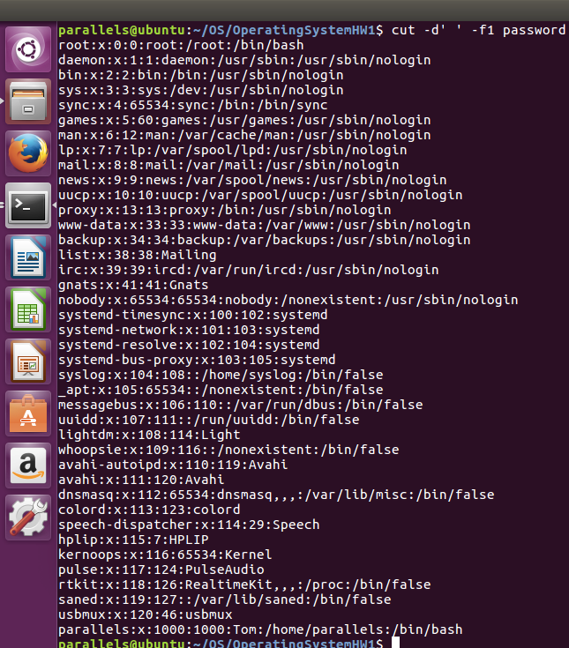

130) as delimenter ' ' it takes every row and prints characters from 1st to 10th

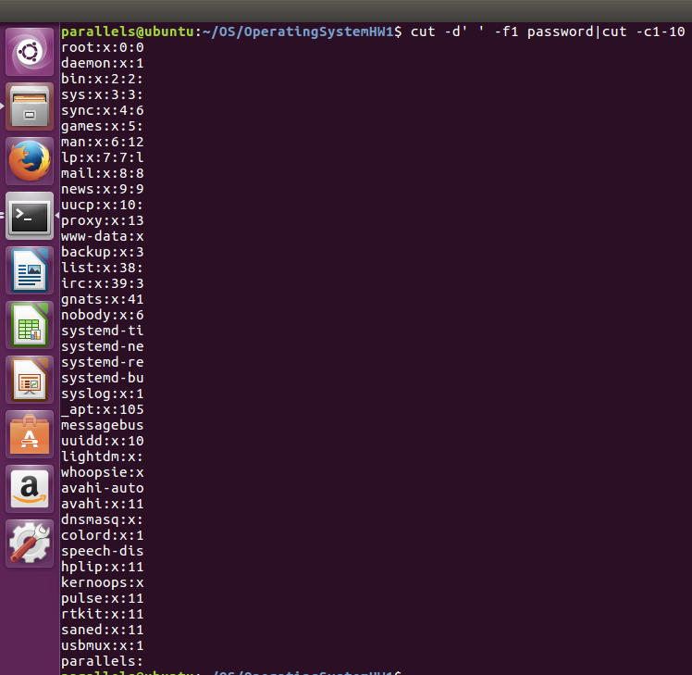

131) it revers the content and shows 1st element of an array which is spleetted by delimeter

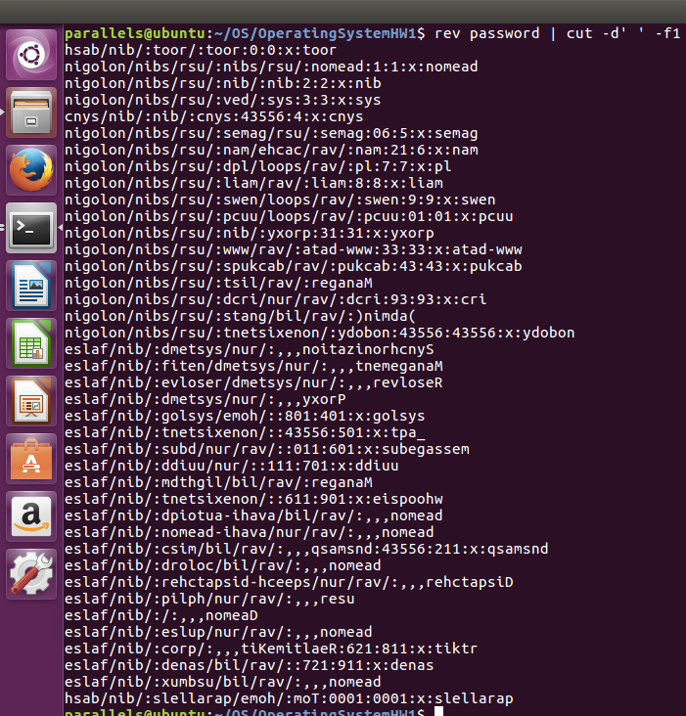

132) prints characters from 10th till 50th character of reverse content of file

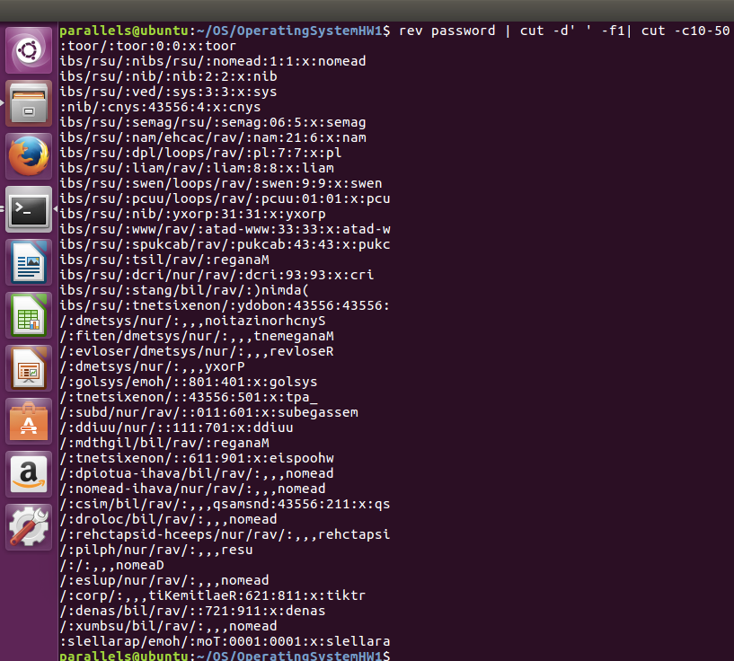

133) prints the lines where it contains word CHOICE in select.sh file

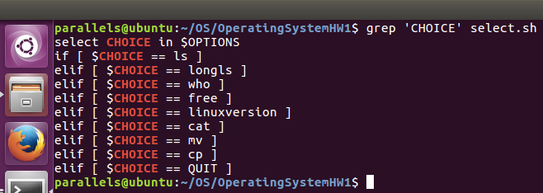

134) prints the lines where it contains word 'echo' in case.sh file

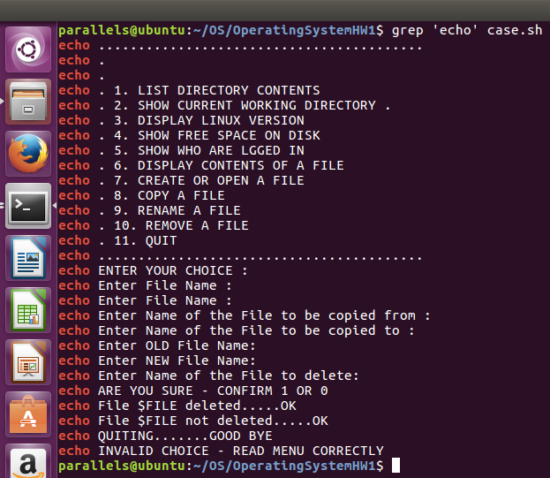

135) prints every new line which starts with small letters (it is given as regex) in file

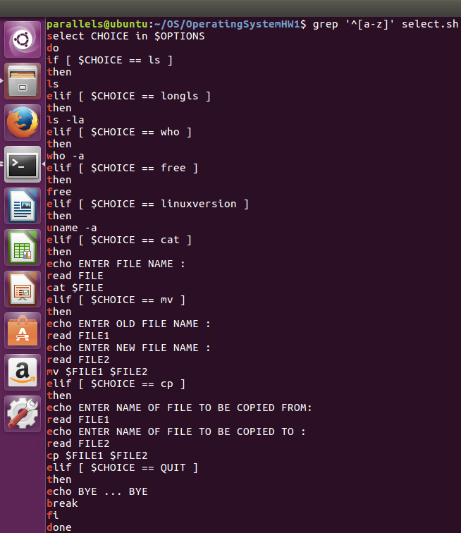

136) prints every new line which starts with capital letters (as given in regex) in file

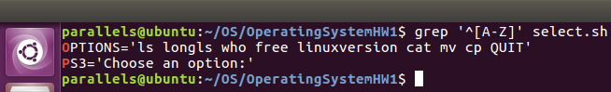

137) prints every new line which starts numbers (as given in regex) in file

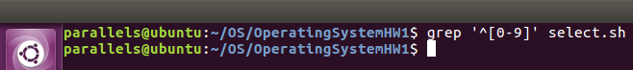

138) prints every new line which starts with space ' ' in file



139) reads every file recursively and find line exact maches with given string 'esac', then prints filename and line

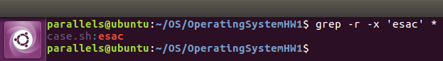

140) prints files which does not contain string 'esac' in current directory

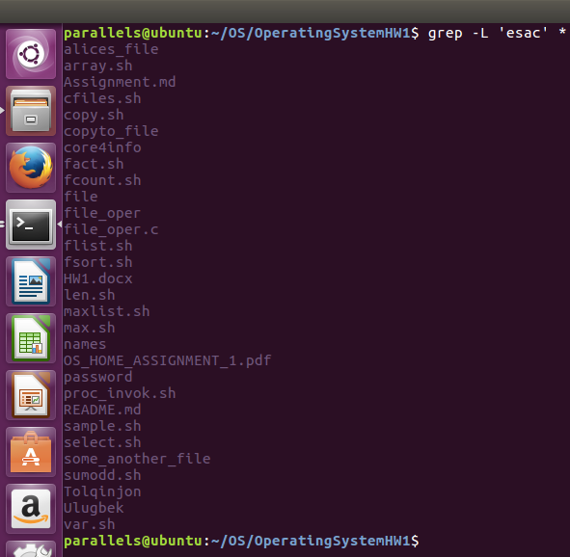

141) prints files which contains the string 'file' in current directory

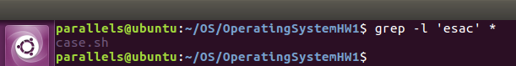

142) prints files and lines which matches with string 'esac'

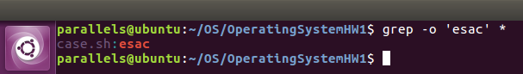

143) print files with any name with any extension and lines which matches with string 'esac'

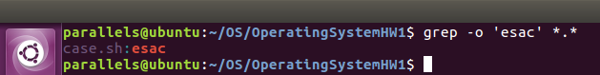

144) prints files with any name with any extension and lines which matches with string 'case'

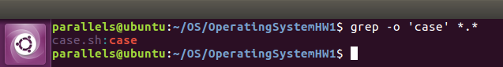

145) prints files with any name with any extension and lines with line number which matches with string 'case'

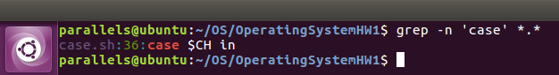

146) prints only matched lines with string 'case' in case.sh file

147) prints line number and matched line with string 'esac' in case.sh file

148) prints line number and matched line with string 'case' in case.sh file

149) prints line which matched with string 'case' in case.sh file

150) prints line which matched with string 'echo' in case.sh file

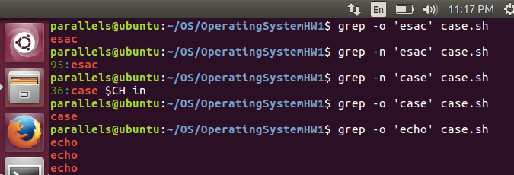

151) 1st it takes echo matched lines and prints count of lines

152) prints byte offset of matched string 'case' in file case.sh

153) prints only matched results with line number and byte offset in file case.sh

154) prints byte offset, line number with full line which matched with string 'case'

155) prints byte offset for every match

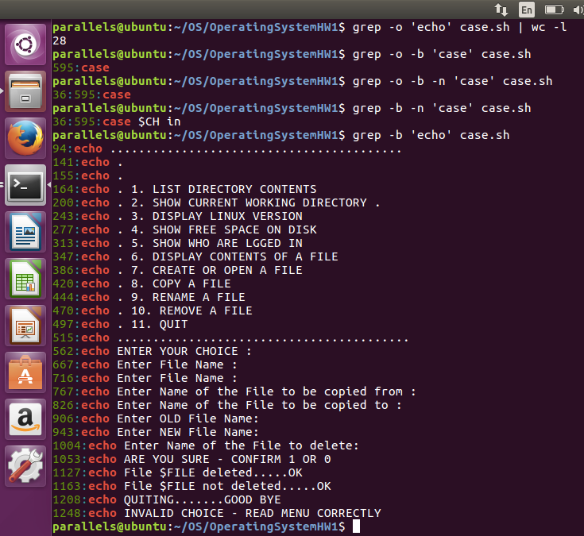

156) prints only matches with byte offset and line number in file case.sh

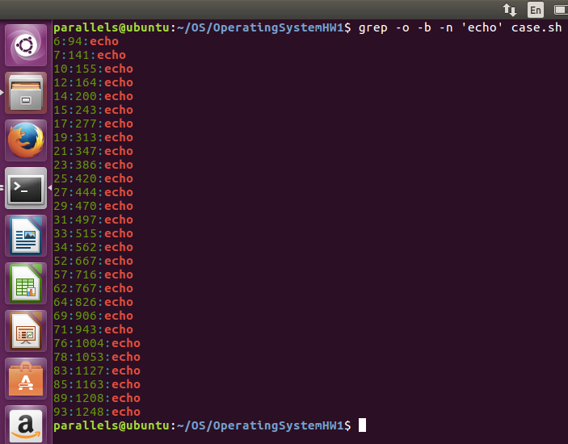

157) prints byteoffset, line number of matched string with full line

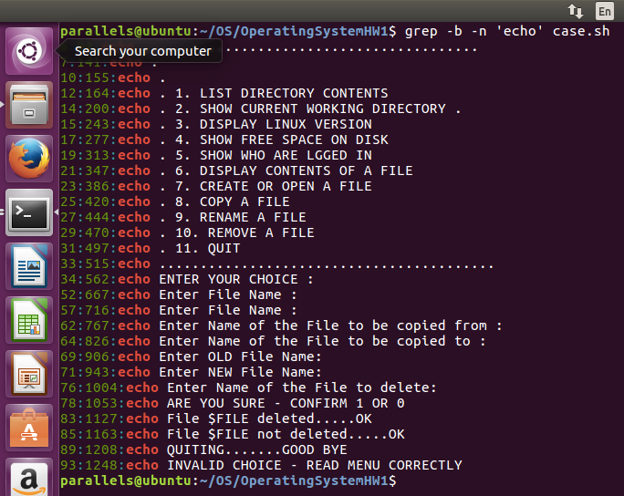

158) prints byte offset of matched string

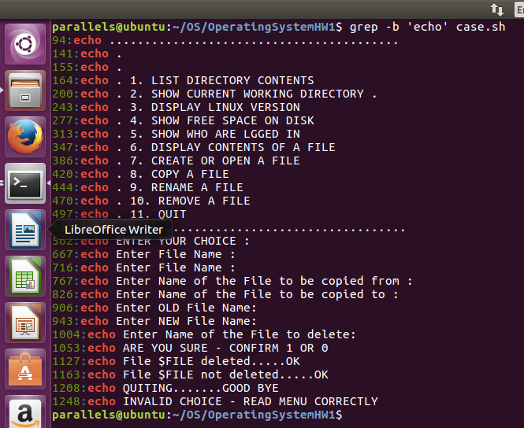

159) prints matched string line and line number

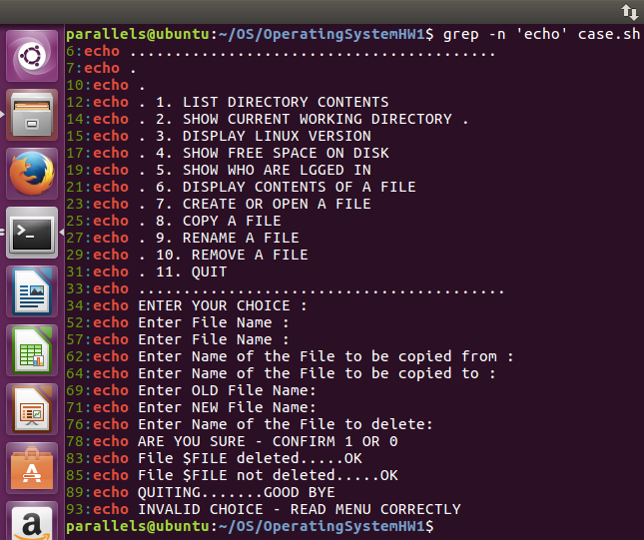

160) prints lines which starts with 'case' string in case.sh file

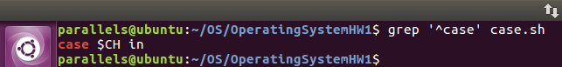

161) prints lines which ends with string 'OK' in case.sh file

162) prints lines which ends with string 'ne' in case.sh file

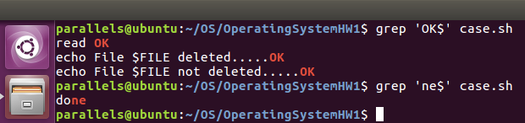

163) prints lines which ends with character ':' in case.sh file

164) prints lines which starts with 'while' string in case.sh file

165) prints lines which starts with 'echo' string in case.sh file

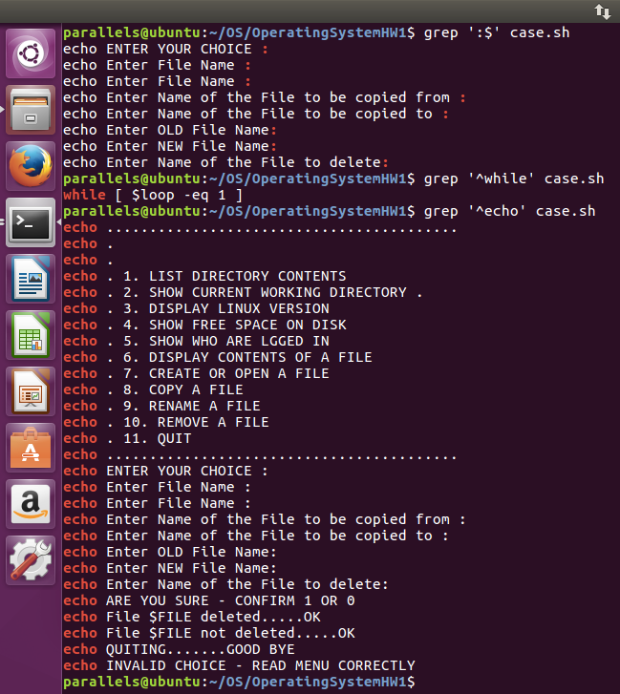

166) prints lines which does not match with string 'echo' in case.sh file

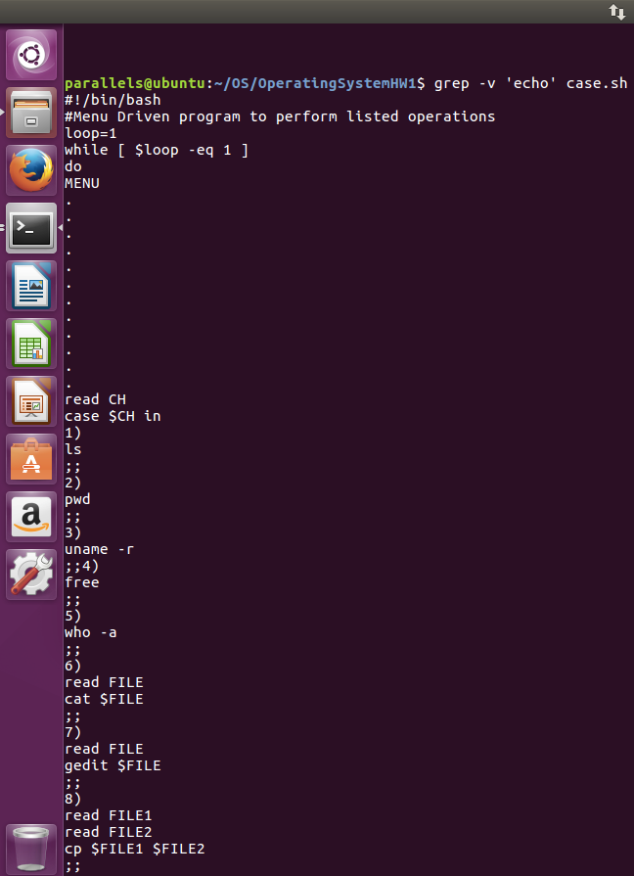

167) prints lines which does not start with string 'echo' in case.sh file

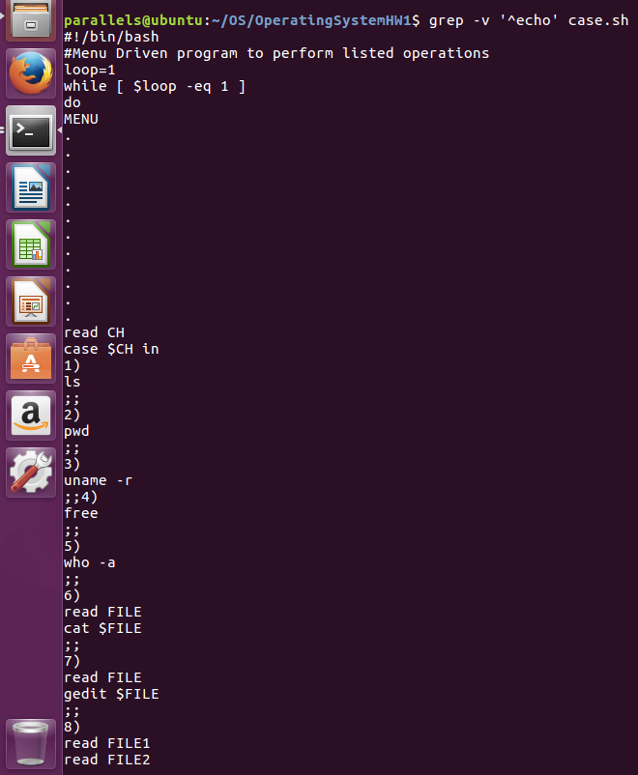

168) prints lines which does not start with string 'while' in case.sh file

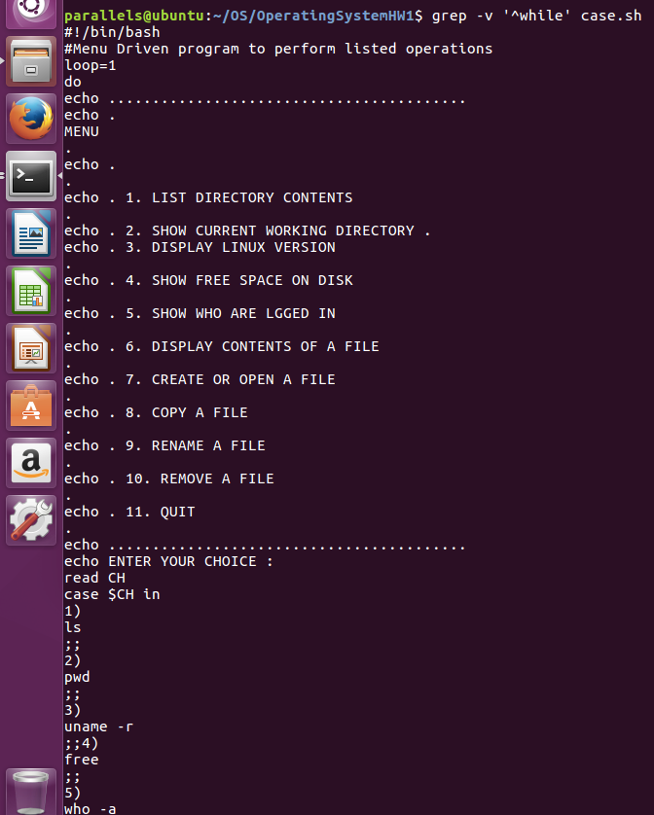

169) prints count of matches 'case' string in case.sh file

170) prinst count of matches 'echo' string in case.sh file

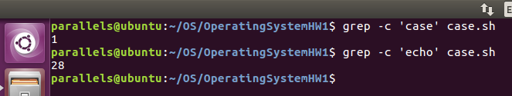

171) prints count of matches 'unix' string in file.txt file

172) print lines which matches with string 'read' in case.sh file

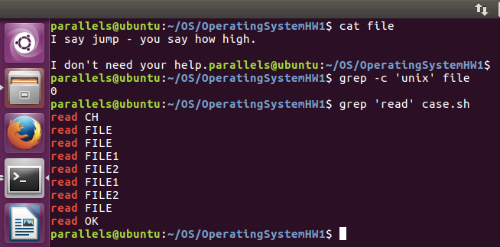

173) prints only matched with string 'read' as regex in file case.sh

174) prints line countes of matched string 'read' in case.sh

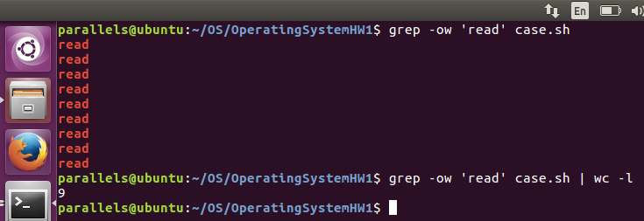

175) append next strings which ends with command+D to part2q file

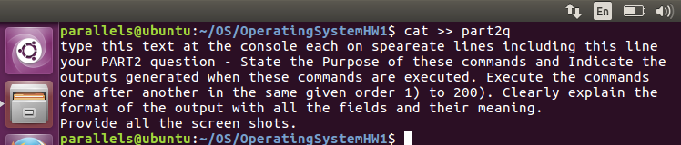

176) prints 3rd line of part2q file

177) prints matched words on 3rd line

178) prints count of matched words on 3rd line

179) prints 1st line of part2q file

180) prints count of matched words on 1st line

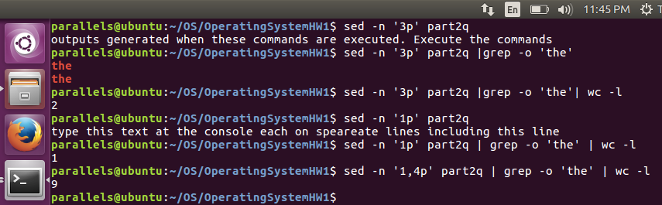

181) sed --n '1,4p' part2q | grep -o "the" | wc -l - shows how many the word "the" have in first line in file part2q

182) sed 's/the/THE/' part2q - replace "the" to "THE" in each line of file part2q,

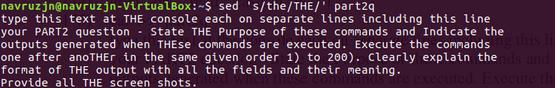

183) sed 's/THE/the/g' - globally replace "THE" to "the" in file part2q

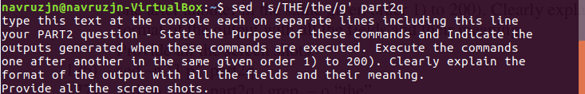

184) sed 's/the/THE/2' - replace second occurence "the" to "THE" in file part2q

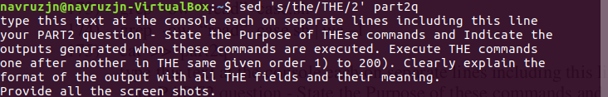

185) sed 's/the/THE/3' - replace third occurence "the" to "THE" in file part2q

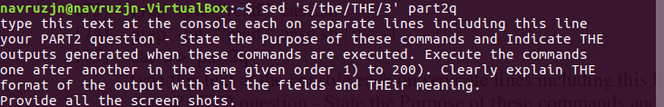

186) sed 's/the/{&}/' part2q - replace the first occurrence "the" to "{the}" in each line of file part2q, in another words put "the" into brackets "{}", however it will replace only first occurence in each line

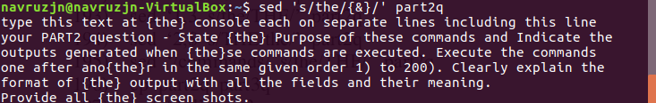

187) sed 's/the/THE/p' part2q - replace "the" to "THE" in each line of file part2q and print every line after original to show changes

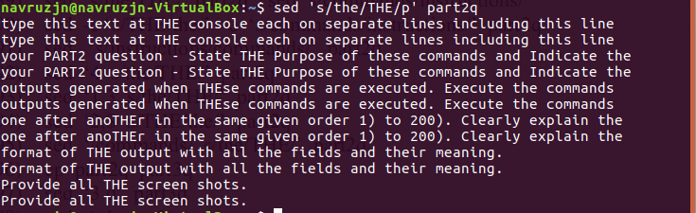

188) sed --n 's/the/THE/p' part2q - replace "the" to "THE" in each line of file part2q and print only changed lines after original

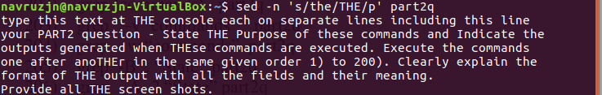

189) sed 's/the/THE/' part2q | sed 's/commands/instructions/' part2q - replace "the" to "THE" then "commands" to "instructions" in each line of file part2q, however it will replace only first occurence in each line

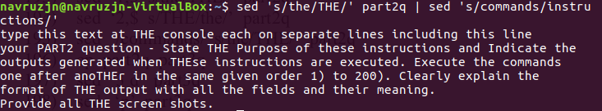

190) sed -e 's/the/THE/' part2q -e sed 's/commands/instructions/' - add the script to the sed to be executed, that first replace every first occurence "the" to "THE" then "commands" to "instructions" in each line of part2q

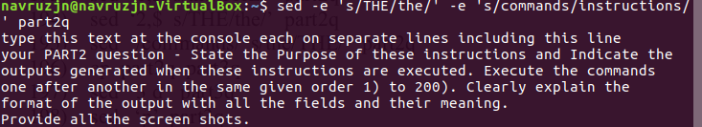

191) sed 's/instructions/commands/' - replace every first occurence in each line of part2q "instructions" to "commands"

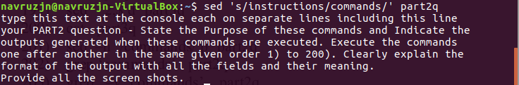

192) sed '4 s/the/THE/' part2q - replace first occurence "the" to "THE" in 4th line of file part2q

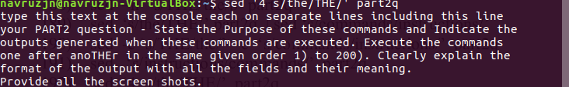

193) sed '1,3 s/the/THE/' part2q - replace first occurence "the" to "THE" in 1st and 3rd lines of file part2q

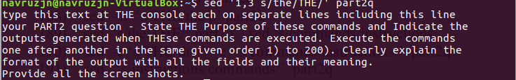

194) sed '2,$ s/THE/the/' part2q - replace first occurence "THE" to "the" in from 2nd line of file part2q

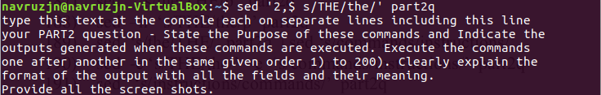

195) sed '/commands/ s/the/THE/' part2q - replace first occurence "the" to "THE" which comes before the "commands" in sentences of part2q

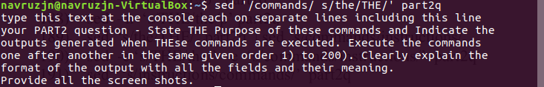

196) cp part2q part3q - create copy of part2q as part3q in the same direction

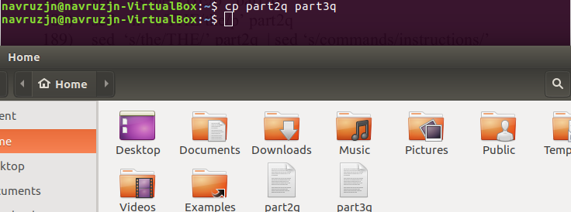

197) sed '3 d' part3q - delete 3 rd line in file part3q

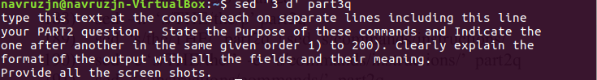

198) sed 'p' part3q - print every changed line to show changes in file part3q

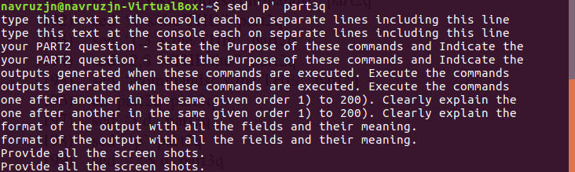

199) sed '2,$ d' part3q - delete from 2nd line in file part3q



200) cat part3q - Concatenate part3q to standard output.

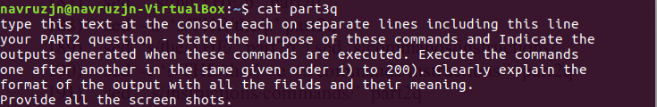

201) sed --n 'commands/p' part3q - print every line which has "commands" to show after original in file part3q

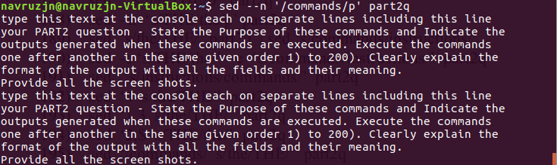

202) grep 'commands' part2q - search for and print only lines where has "commands" and highlight



203) grep -v 'commands' part2q - search for and select non-matching lines where has "commands" for print

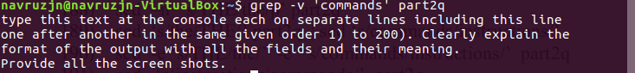

204) grep -w 'commands' part2q - force pattern to match only whole word "commands"



205) grep -B2 'State' part2q - print 2 lines of leading context till last "State"



206) grep -A2 'State' part2q - print 2 lines of trailing context from "State"



207) grep -C2 'State' part2q - print 2 lines of output context where "State"

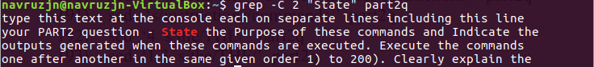

208) grep -B2 'and' part2q - print 2 line of leading context till last "and"

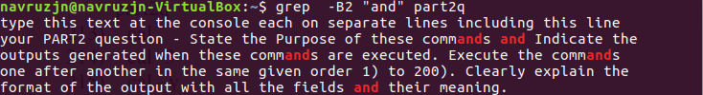

209) grep -A2 'and' part2q - print 2 line of leading context from first "and"

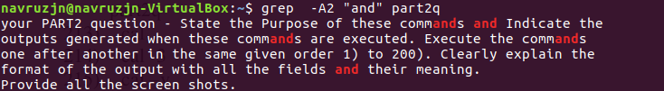

210) grep -C2 'and' part2q - print 2 lines of output context where "and"

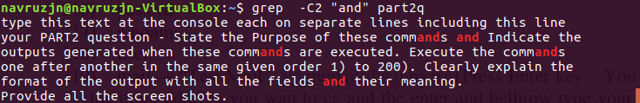

211) sed --n 'commands/!p' part2q - does not print lines which has "commands" to show after original in file part2q

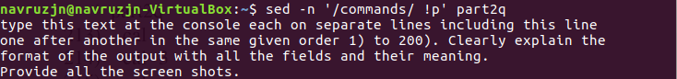

212) sed '/commands/ a "You need to learn these commands which are very essential"' part2q - replace the text equivalent to 'You need to learn these commands which are very essential'

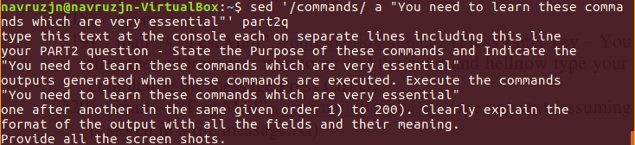

213) cal - print calendar of current month

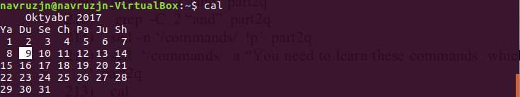

214) cal -3 - print calendar including three months that 'current month-1' 'current month' 'current month+1'

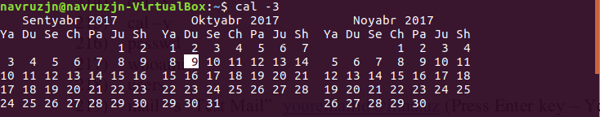

215) cal -y - print calendar of current year

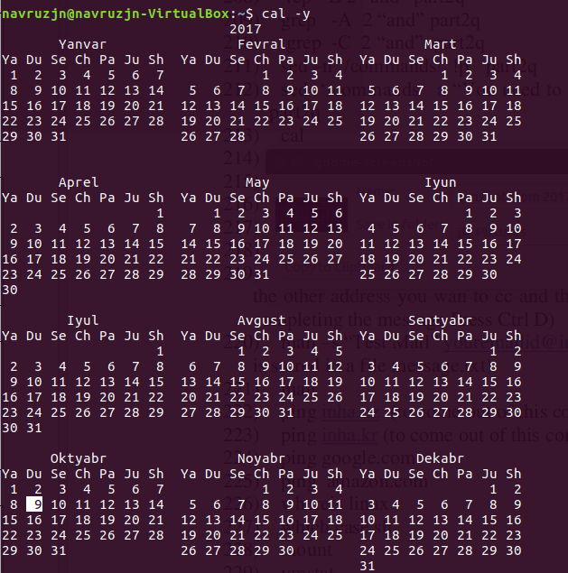

216) passwd - change UNIX password used to login associated with the current effective user ID

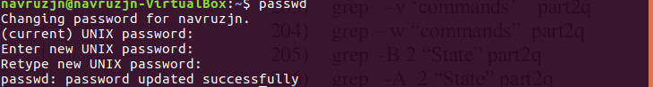

217) whoami - print the user name associated with the current effective user ID



218) users - prints the user names associated with all effective user IDs



219) mail -s "Test Mail" n.jandullaev@student.inha.uz - send a message with the given "I want to sleep, I want to eat" to n.jandullaev@student.inha.uz from "Test mail"

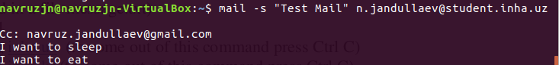

220) mail -s "Test Mail" n.jandullaev@student.inha.uz <message.txt - send a message with from message.txt to n.jandullaev@student.inha.uz from "Test mail"



221) mail - prints all messages

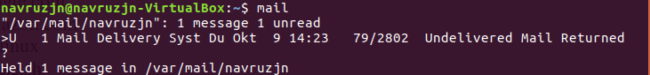

222) ping inha.uz - check connection and print how many packages loses during request/response with "inha.uz"

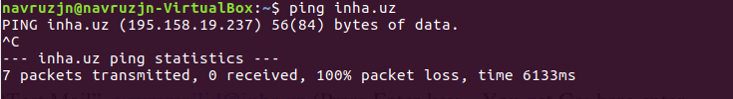

223) ping inha.kr - check connection and print how many packages loses during request/response with "inha.kr"

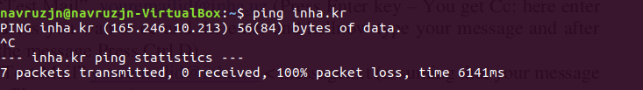

224) ping google.com - check connection and print how many packages loses during request/response with "google.com"

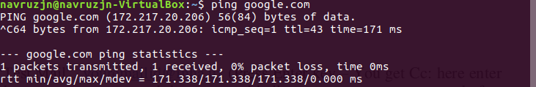

225) ping amazon.com - check connection and print how many packages loses during request/response with "amazon.com"

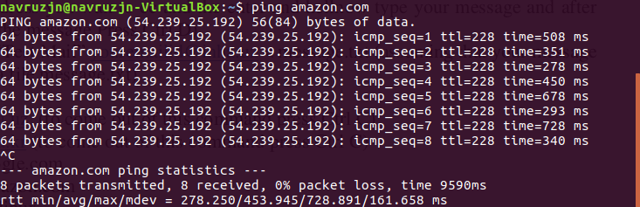

226) whereis linux - locate the binary, source, and manual-page files for a command in directory of linux.



227) which ./case.sh - command to locate path for case.sh, this command is really helpful to find path of executable commands that user don't know about its location.

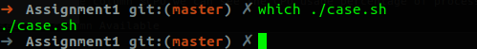

228) mount - mount a filesystem

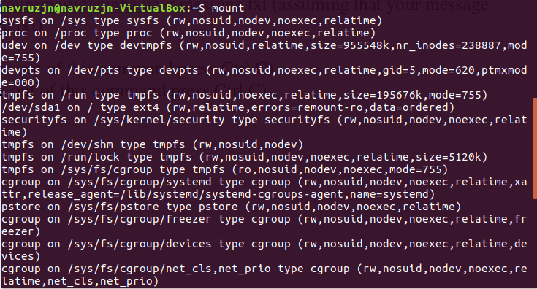

229) vmstat - Report virtual memory statistics



230) netstat - active internet connections ip and pid

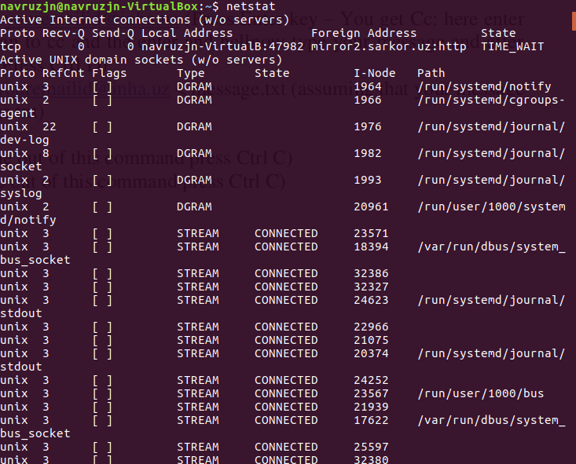

**2B**

1. find . -type l

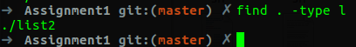

2. touch fileop.c

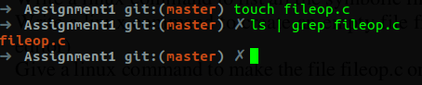

3. chmod --verbose a-rwX,u+r fileop.c

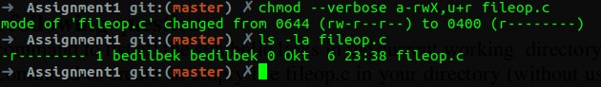

4. uname -a

After entering this command we will see all the information about operation system, and wee see that Ubuntu is running on this Linux

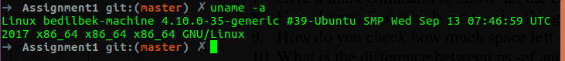

5. First we will run a process (Gnome editor) by its command `gedit`.

now we will suspend it by pressing the buttons (^Z).

After executing `bg %gedit` command gedit will continue running in background.

After executing `fg %gedit` command gedit will continue running in foreground.

Now we will suspend it by pressing the buttons (^Z).

Now if we write `bg` command itself, then it will bring the first process that is in foreground to background.

So now gedit is running in background.

We can find the pid of this process by executing the command `ps -la`.

Now with the found pid we will terminate the process: `sudo kill 9 12703`.

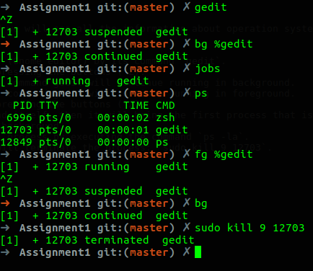

6. to know if remote host is alive we will use command `ping`

ping -c 3 google.com

we are sending 3 packets to google.com to know if the service is alive or not

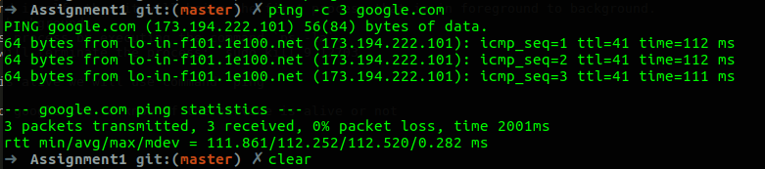7. to know history of earlier command we will use command `history`

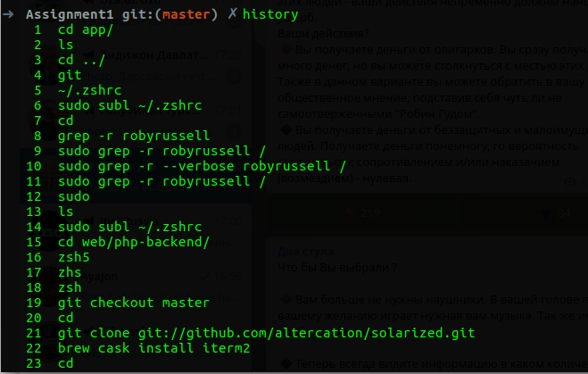

8. we will use command `top` to find which process is taking how much time, and in the column %CPU we can see the CPU usage percentage of processes

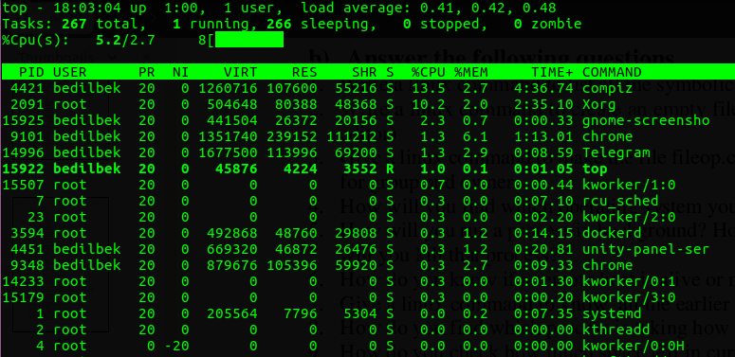

9. to check how much space left in the disk, execute command `df -h` and see the column Available

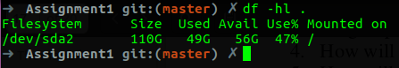

10. `ps -a` option causes ps to list all processes created within this terminal

`ps -ef` options cause `-e` option to list all processes and `-f` option to add extra columns of full information about the running processes

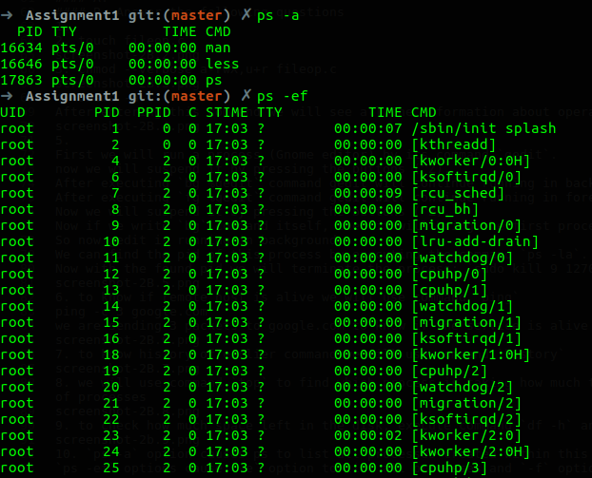

11. to find number of processors we use command `nproc` or `grep -E 'cpu cores' /proc/cpuinfo` or from saved file `grep -E 'cpu cores' infocpu`

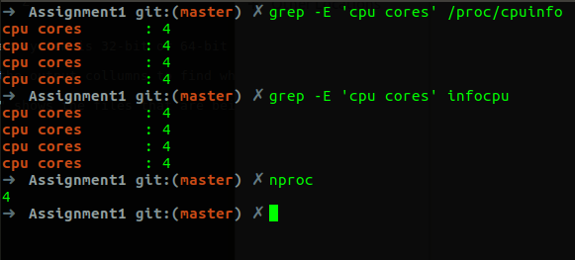

12. we will use ps and grep to find running zombie processes

`ps axo stat,ppid,pid,tty,time,cmd | grep -e '^Z'`



13. we will use command `find / -name 'part2q' -print` to find file part2q starting from root directory



14. `uname -m` or `arch` commands find whether system is 32-bit or 64-bit

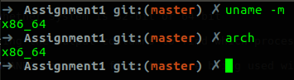

15. We can use command `ps` with formatting the output collumns to find which process is accessing which file

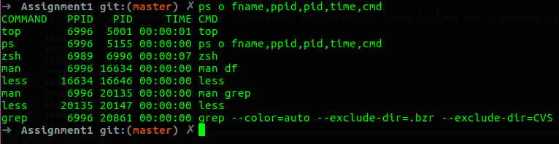

Here in the screenshot first column "COMMAND" shows the files that are being used with corresponding processes

16. we will use command `sed -i 's/the/THE/g' part2q` to replace all occurences of the with THE

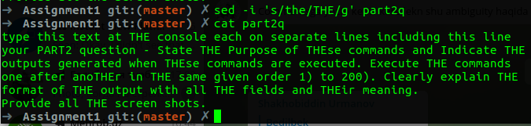

17. `cut -b11-12 listdir`

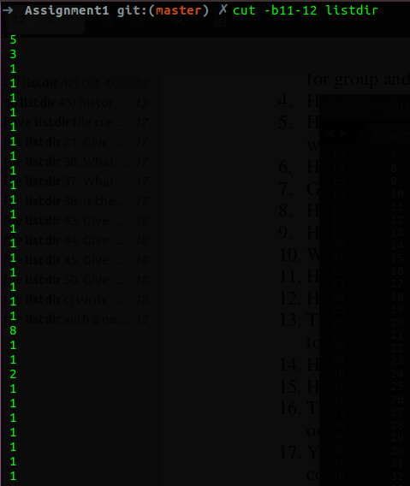

18. we will use `du` command with `-h` option to add human readability and `-d` option to determine depth of recursive accessing to directories in home directory to find space usage of directories there

sudo du -hd 1

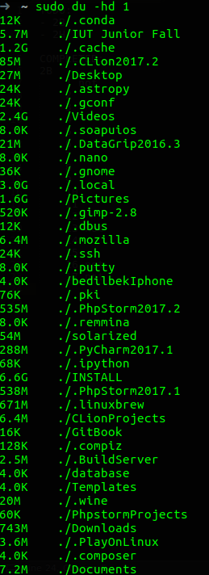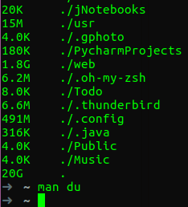

19. to find how long system is up `uptime -p` -o option to prettify the output

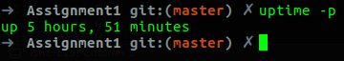

20. `rev listdir | tee listdir` command displays all lines of listdir in reverse order and writes output to listdir file

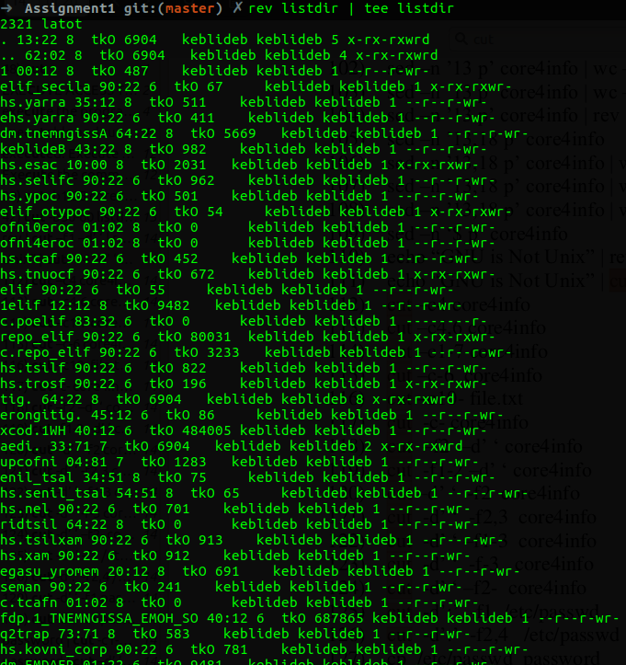

21.

first use command `top` to list all running processes.

there are two ways to sort by cpu usage.

1) press `F` button, select `%CPU` and press button `s` and press `Esc`, now processes are sorted by CPU usage

2) press button `<` or `>` until sorting reaches `%CPU`

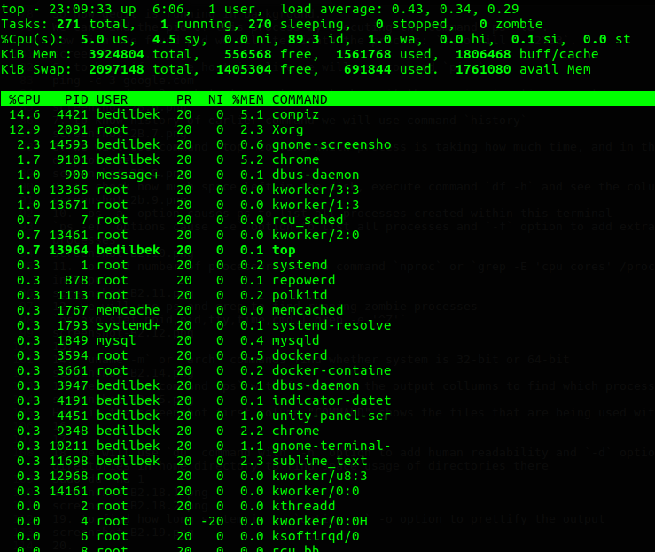

22. to display 10 lines of case.sh we will use command `head -10 case.sh`

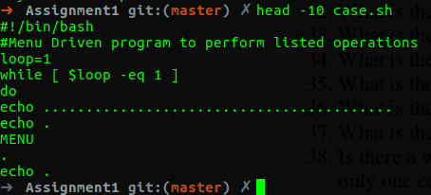

23. to display last 5 lines of case.sh we will use command `tail -5 case.sh`

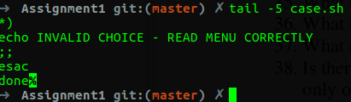

24. we will use command `tar cvzf hw1.tar.gz HW1.docx` to compress HW1.docx

an then use command `tar xvzf hw1.tar.gz` to decompress that file

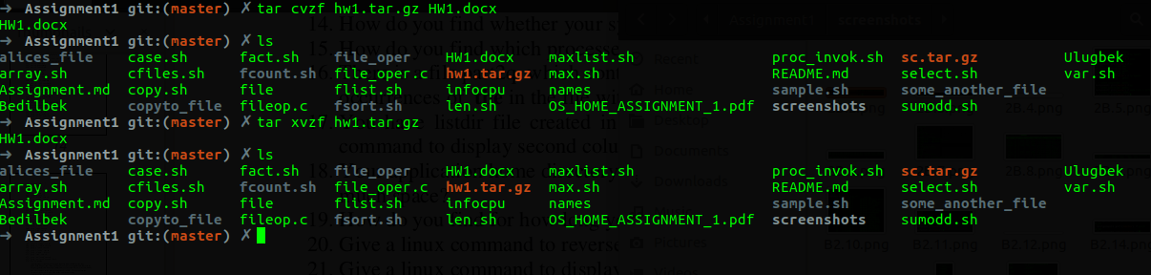

25. we will use command `cat -n` to display lines of file along with line number

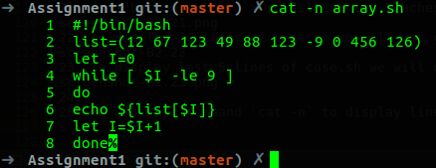

26. we will use command `chmod -v +x case.sh` to give execution access to all

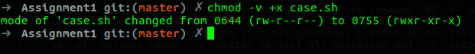

27. asks the user to delete all files in the current directory, if user presses button `y` then it deletes all files in that directory

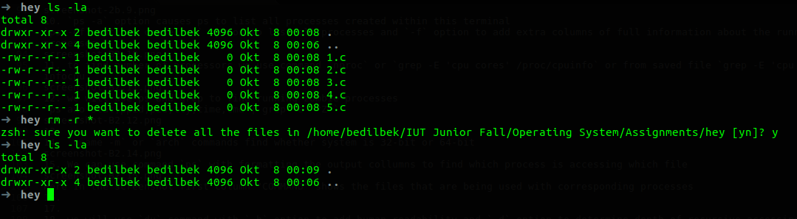

28. diff compares files line by line, whereas cmp compares byte by byte.

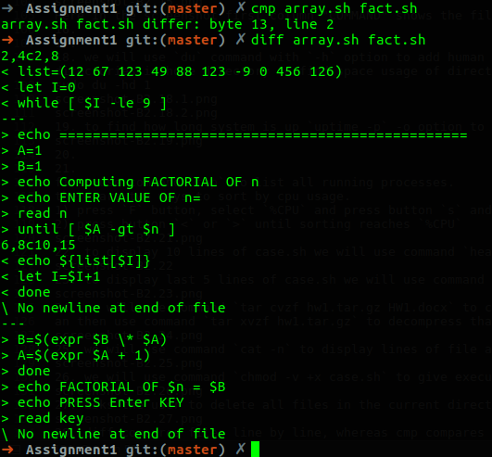

29. `more -1 array.sh` and `head -1 array.sh` can be used to display first line of array.sh

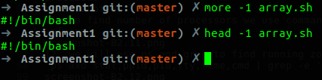

30. 'tail -1 array.sh' and 'less -X array.sh' can be used to display last line of array.sh

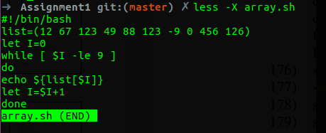

31. to find the process that is taking maximum memory we will use command `ps` and `sed`

`ps -eo ppid,pid,cmd,%mem --sort=-%mem | sed -n -e '1 p' -e '2 p'` this command formats the output of processes and sorts them by memory percentage in descing order, so we know that 1 row will be format and 2 row will be the process that we are seeking for

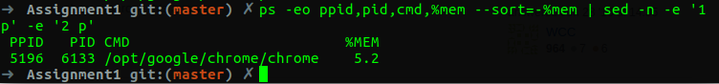

Here in the screenshot we see that google chrome is taking maximum memory 5.2% on my system.

32. to find only hidden files in current directory we can use command `find . -type f -iname ".*"`

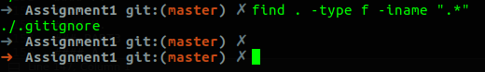

33. to find currently running process we can dissplay all processes and by filtering we can get only running ones.

`ps -eo state,ppid,pid,time,cmd | grep '^R'`



34. `df -h /` by executing this command and seing the column Available can give a information about remaining disk space on system

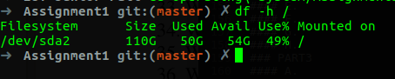

35. `wc --lines listdir` command is used to count number of lines in listdir

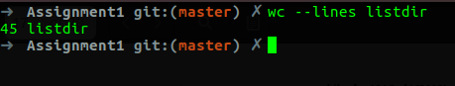

36. `wc --words listdir` command is used to count number of words in listdir

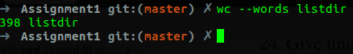

37. `wc --chars listdir` command is used to count number of characters in listdir

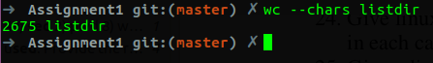

38. yes, by command `rm -r *` all files and subdirectories can be deleted

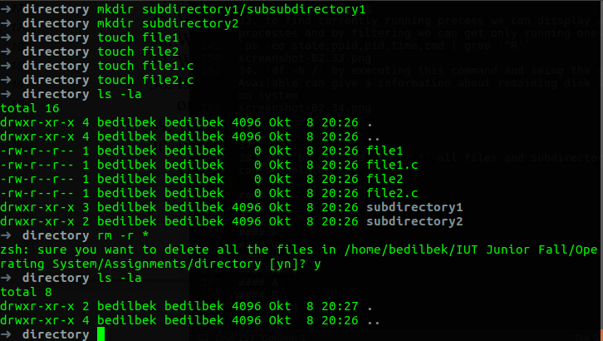

39. tee command is used to read from input and write to standard output and files. For example:

`ps -o pid,tty,time,cmd,%mem --sort=%mem | tee memory_usage`

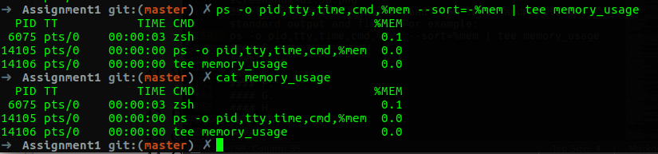

40. `env` by executing this command, it displays environment variables

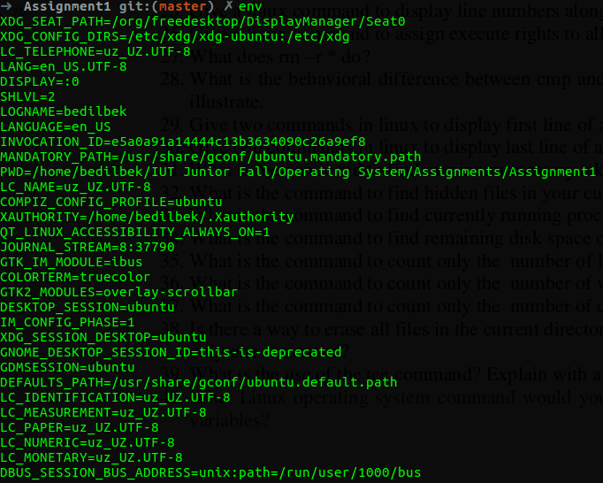

41. difference between ls -la > file1 and ls -la > file1 2>&1 is if execution of second command throws exception then it will write that error to the file1, however if there is exception in the execution of first command, it will display to the screen, but will not write to the file

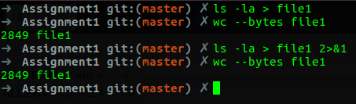

42. first we will display the file with `cat` command, and with `sed` command we will select 8th line, then with `wc` we will count length of line.

`sed -n '8 p' listdir | wc --chars`

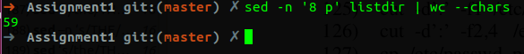

43. `sed -i '1 d' listdir` to delete 1st line of listdir

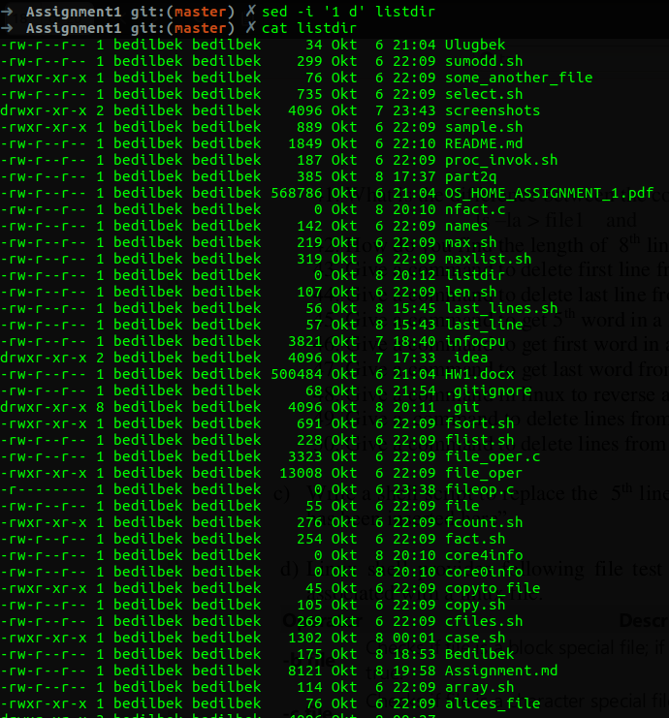

44. 'sed -i '$ d' listdir` to delete last line of listdir

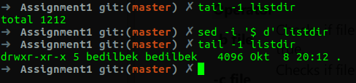

Here we see before and after deletion of last line of listdir

45. `sed -n '1 p' part2q | cut -f5 -d ''

Here firstly, we select first line and then display 5th word that is delimeted with ''

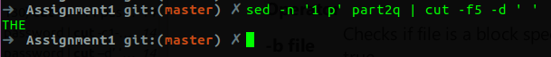

Here in the screenshot we can see that 5th word in first line is 'THE'.

46. `sed -n '1 p' part2q | cut -f1 -d ''`

Here firstly, we select first line and then display first word that is delimeted with ''



Here in the screenshot we can see that first word in first line is 'type'.

47. `sed -n '1 p' part2q | rev | cut -f1 -d '' | rev`

Here firstly, we select first line, then reverse the line, get the first word that is delimeted with '' and reverse it again.



Here in the screenshot we can see that last word in first line is 'line'.

48. `echo "WINE Is Not windows Emulator" | rev`



49. `sed -i '1,5 d' listdir` to delete from 1-5 lines of listdir

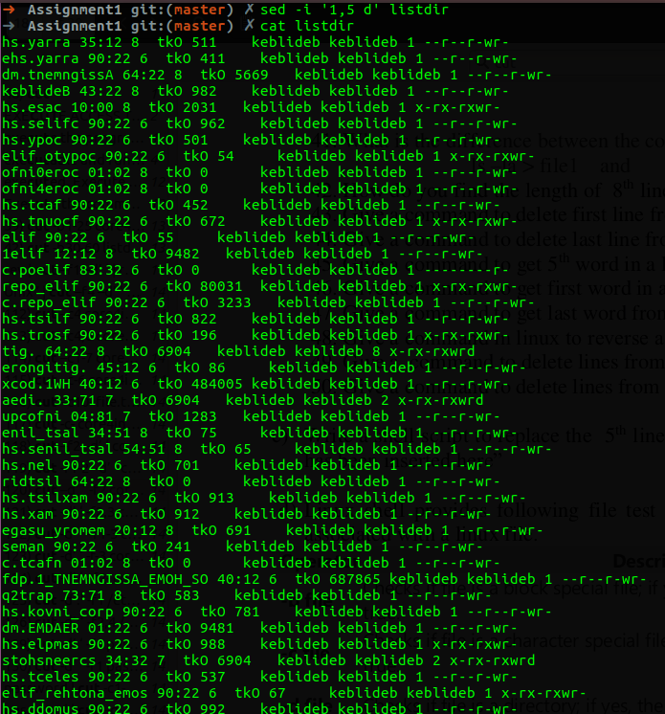

50. `sed -i '15,$ d' listdir` to delete from 15-till the end lines of listdir

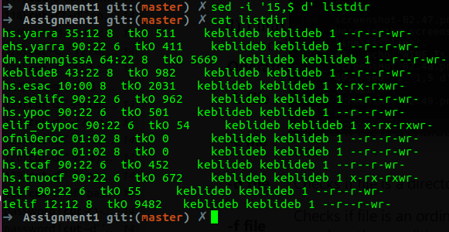

**###################################################################################**

**2C**.

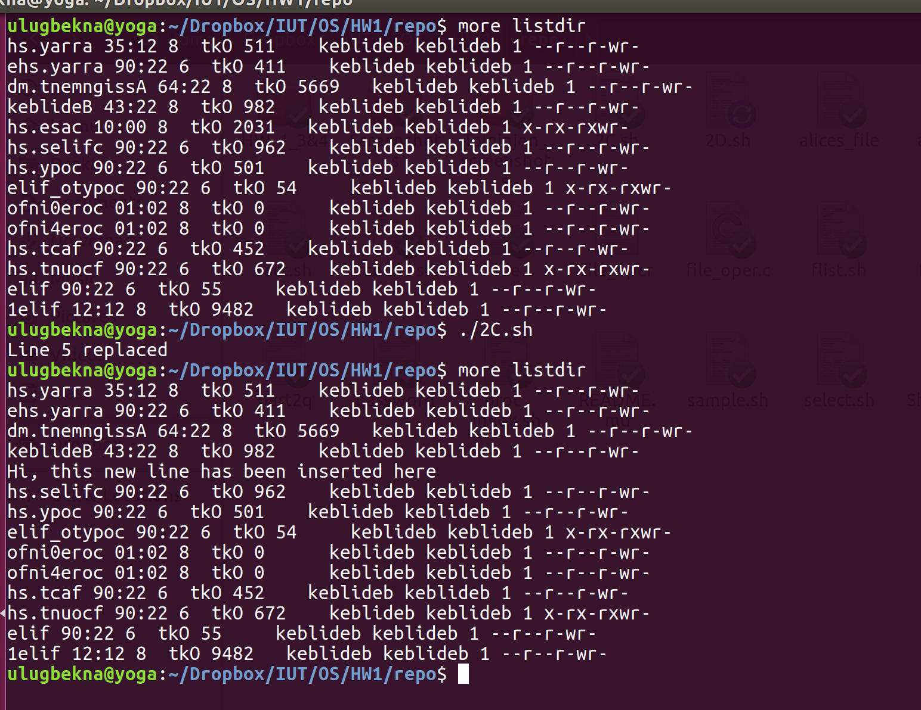

Replaces 5th line of file listdir if the listdir is present; otherwise, it prints that file does not exist.

**###################################################################################**

**2D**.

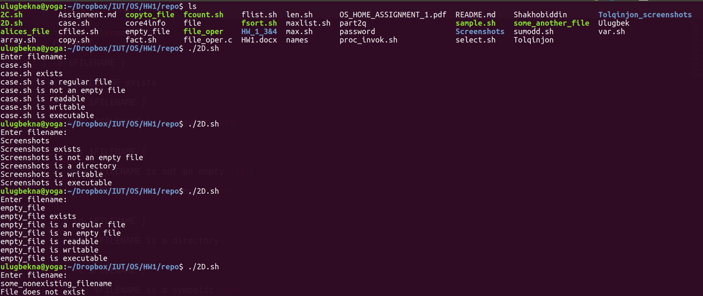

Checks the file with the input name whether it exists, if it is empty, type of file, read/write/execute access

**###################################################################################**

**2E**.

(i)

SCRIPT:

#!/bin/bash

echo Enter n:

read N

echo Enter $N numbers:

let K=0

while [ $K -lt $N ]

do

read VAL

list[$K]=$VAL

let K=$K+1

done

let MAX=${list[0]}

let K=1

while [ $K -lt $N ]

do

if [ $MAX -lt ${list[$K]} ]

then

MAX=${list[$K]}

fi

let K=$K+1

done

echo MAXIMUM ELEMENT HERE IS $MAX

(ii) In this script it is almost the same as in the previous script, but it checks for "greater than".

(iii)

SCRIPT:

...Enter values to list...

echo ENTER KEY:

read KEY

let K=0

let INDEX=-1

while [ $K -lt $N ]

do

if [ $KEY -eq ${list[$K]} ]

then

INDEX=$K

break

fi

let K=$K+1

done

if [ $INDEX -eq -1 ]

then

echo NOT FOUND

else

echo KEY ${list[$K]} FOUND IN the list

echo ITS position is $K starting from 0

fi

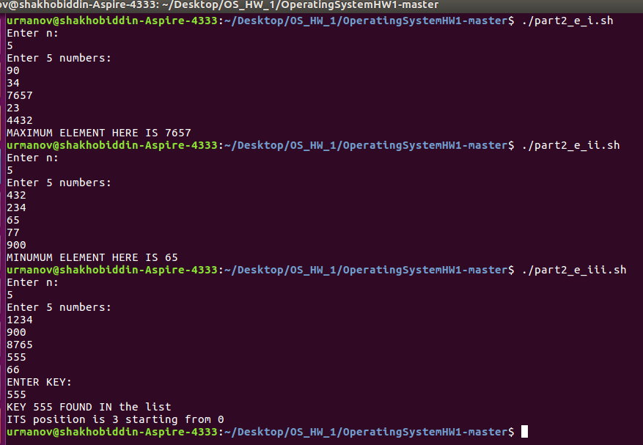.

**###################################################################################**

**2F.**

The command 'sed' was used to substitute.

Scipts:

(i)

sed 's/.*/\U&/g'< part2q > part2ql

echo Letters IN part2q FILE have been UPPERCASED and stored IN part2ql FILE

(ii)

sed 's/.*/\L&/g'< part2q > part2qu

echo Letters IN part2q FILE have been lowercased and stored IN part2ql FILE

(iii)

cat part2q > part2qr

sed -i '/commands/ s/the/THE/g' part2qr

sed -i 's/commands/COMMANDS/g' part2qr

echo In part2q the lines with word \'commnads\' found and the occurencies with \'the\' IN these lines were UPPERCASED and the words \'commands\' as well.

(iv)

cat part2q > part2m

sed -i -e '1 d' part2m

sed -i -e '$ d' part2m

echo First and LAST lines are DELETED from part2m FILEs

(v)

cat part2q part2ql part2qu part2qr part2m > part2qa

echo The contents of part2q part2ql part2qu part2qr part2m FILES were copied and pasted IN part2qa

**###################################################################################**

**2G**

In this script to implement the selection menu, 'select' statement was used.

#!/bin/bash

OPTIONS='Halt init0 init6 Poweroff Reboot Shutdown'

PS3='Choose an option: '

select CHOICE in $OPTIONS

do

if [ $CHOICE == Halt ]

then

sudo halt

elif [ $CHOICE == init0 ]

then

sudo init 0

elif [ $CHOICE == init6 ]

then

sudo init 6

elif [ $CHOICE == Poweroff ]

then

poweroff

elif [ $CHOICE == Reboot ]

then

reboot

elif [ $CHOICE == Shutdown ]

then

shutdown

else echo NO such option

fi

done

##There are results during the execution in the screenshot below

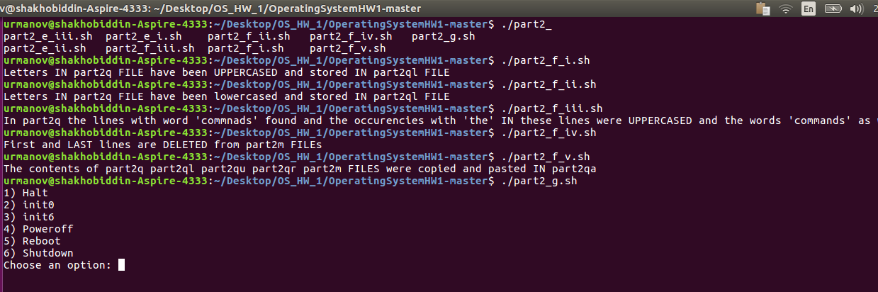

**###################################################################################**

**2H.**

CODE

/* Program using UNIX I/O primitives to perform file operations with menu driven*/

#include <stdio.h>

#include <sys/stat.h>

#include <fcntl.h>

#include <unistd.h>

#include <string.h>

#define DEF_MODE S_IRUSR|S_IWUSR|S_IXUSR|S_IRGRP|S_IWGRP|S_IXGRP|S_IROTH

void createNewFile();

int openExistingFile();

void readFromFile(int fd, int nbytes);

void writeToFile(int fd, int i);

void findInFile(int fd);

void deleteFile();

void renameFile();

void copyFile();

int main()

{

int option = 1;

int fd, len;

char filename[25];

while (option >= 1 && option <= 9)

{

printf("----MENU TO PERFORM FILE OPERATIONS----\n");

printf("1. Create a new file\n");

printf("2. Open an existing file\n");

printf("3. Read from a file\n");

printf("4. Write to a file\n");

printf("5. Seek the contents of the opened file\n");

printf("6. Delete a file\n");

printf("7. Rename a file\n");

printf("8. Copy a file\n");

printf("9. Quit\n");

printf("Choose an operation (1-9) : ");

scanf("%d", &option);

switch(option)

{

case 1: createNewFile();

break;

case 2: fd = openExistingFile();

break;

case 3: readFromFile(fd, 0);

break;

case 4: writeToFile(fd, 0);

break;

case 5: findInFile(fd);

break;

case 6: deleteFile();

break;

case 7: renameFile();

break;

case 8: copyFile();

break;

case 9: return 0;

default: printf("Entered wrong option, try again later, PLEASE");

break;

}

}

}

void createNewFile()

{

int fd, fsize;

char ch=0, buf[512], fname[25], cname[25];

printf("CREATING A NEW FILE WITH ALL ACCESS RIGHTS TO USER AND GROUP AND NO EXECUTE ACCESS TO OTHERS\n");

printf("ENTER FILE NAME : ");

scanf("%s", fname);

fd = open(fname, O_CREAT|O_TRUNC|O_WRONLY|O_APPEND, DEF_MODE);

if (fd < 0)

printf ("cannot create FILE %s \n", fname);

else

{

printf("FILE %s CREATED", fname);

close(fd);

}

printf("\n\n");

}

int openExistingFile()

{

/**

TODO: complete

**/

int fd, option, mode;

char ch=0, cf, buf[512], fname[25], cname[25];

printf("OPENING AN EXISTING FILE\n");

printf("ENTER FILE NAME : ");

scanf("%s", fname);

printf("PLEASE CHOOSE THE MODE: \n");

printf("1.READ ONLY; 2.WRITE ONLY WITH APPEND; 3.READ & WRITE WITH APPEND : ");

scanf("%d", &option);

switch(option)

{

case 1: mode = O_RDONLY;

break;

case 2: mode = O_WRONLY|O_APPEND;

break;

case 3: mode = O_RDWR|O_APPEND;

break;

default: printf("Please choose correct mode! \n");;

break;

}

fd = open(fname, mode, DEF_MODE);

if (fd < 0)

printf ("cannot open FILE %s - does not exist \n", fname);

else

printf("File %s opened\n\n", fname);

return fd;

}

void readFromFile(int fd, int nbytes)

{

int offset;

char buf[512];

printf("HOW MANY BYTES YOU WANT TO READ, IF TILL THE END, ENTER -1 : ");

scanf("%d", &offset);

if (fd < 0)

printf ("cannot open FILE - does not exist \n");

else

{

int len;

read(fd, buf, sizeof(buf));

if (offset == -1) {

len = 512;

}

else {

if (nbytes != 0)

len = offset + nbytes;

else len = offset;

}

for (int i = nbytes; i < len; i++)

{

if (buf[i] == '\0')

break;

printf("%c", buf[i]);

}

}

printf("\n\n");

}

void writeToFile(int fd, int i)

{

char ch=0, buf[512];

printf("WRITING TO AN EXISTING FILE\n");

if (fd < 0)

printf ("Cannot open a FILE for writing \n");

else if (i >=512)

printf ("Cannot write to a file, range exceeded \n");

else

{

printf("NOW ENTER YOUR PROGRAM OR TEXT LINE BY LINE- ONCE YOU FINISH PRESS KEYS Ctrl D together\n");

ch=getchar();

/* to remove the last newline character entered*/

while((ch=getchar()) != EOF)

buf[i++]=ch;

buf[i]='\0';

printf("\nTotal characters stored in your file = %d\n", i);

write(fd, buf, i);

}

printf("\n\n");

}

void findInFile(int fd)

{

/**

TODO: complete

**/

int nbytes, option;

printf("SEEKING THE CONTENTS FROM AN EXISTING FILE\n");

printf("HOW MANY BYTES YOU WANT TO TO BE SKIPPED, TO GO TO THE END, ENTER -1: ");

scanf("%d", &nbytes);

if (fd < 0)

printf ("Cannot open FILE - does not exist \n");

else if (nbytes < 0)

printf("Entered wrong parameters for seeking, try again with different values\n");

else

{

printf("What kind of operation you want? 1.READ; 2.WRITE : ");

scanf("%d", &option);

if (option == 1) {

readFromFile(fd, nbytes);

}

else if (option == 2)

{

writeToFile(fd, nbytes);

}

else {

printf("Wrong option has been choosen, please try again with different value\n");

}

}

printf("\n\n");

}

void deleteFile()

{

char cf, fname[25];

printf("DELETING A FILE \n");

printf("ENTER FILE NAME :");

scanf("%s", fname);

getchar(); /* to remove the last newline character entered*/

printf("PLEASE CONFIRM -SURE YOU WANT TO DELETE ....PRESS y/n :");

scanf("%c", &cf);

if (cf == 'y')

{

unlink(fname);

printf("FILE %s deleted OK......\n", fname);

}

else

printf("FILE %s not deleted OK......\n", fname);

printf("\n\n");

}

void renameFile()

{

char fname[25], cname[25];

printf("RENAMING A FILE \n");

printf("ENTER CURRENT FILE NAME :");

scanf("%s", fname);

printf("ENTER NEW FILE NAME :");

scanf("%s", cname);

printf("FILE %s has been renamed to %s OK......\n", fname, cname);

rename(fname, cname);

printf("\n\n");

}

void copyFile()

{

int fd, fd1, len;

char buf[512], fname[25], cname[25];

printf("COPYING A FILE \n");

printf("ENTER NAME OF CURRENT FILE TO BE COPIED FROM :");

scanf("%s", fname);

printf("ENTER NAME OF NEW FILE NAME TO BE COPIED TO :");

scanf("%s", cname);

fd = open(fname, O_RDONLY, DEF_MODE);

if (fd < 0)

printf ("cannot open FILE %s - does not exist \n", fname);

else

{

if(read(fd, buf, sizeof(buf)) <0)

printf("FILE READ ERROR\n");

else

{

fd1 = open(cname, O_CREAT|O_TRUNC|O_WRONLY, DEF_MODE);

if (fd1 < 0)

printf("Cannot create New file %s\n", cname);

else

{

len=strlen(buf);

if(write(fd1, buf, len) < 0)

printf("FILE WRITE ERROR\n");

else

printf("FILE %s has been copied to %s successfully OK ......\n",fname,cname);

close(fd1);

}

close(fd);

}

}

printf("\n\n");

}

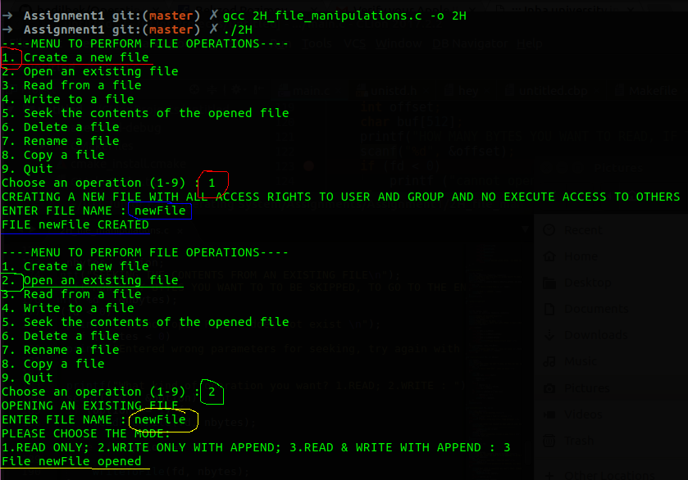

Here from the menu of our program we choose 1st option to create new File.

After completing the given steps we see the message that new File created

Then after completing file operation, again menu is shown

In this part, we will open the file

We choose the option 2 to open the newFile

After completing the given steps we see the message that newfile is opened

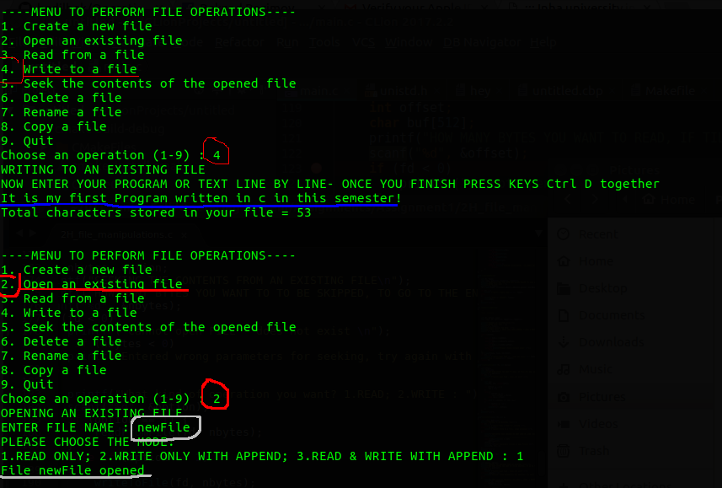

Here by choosing the option 4 to write to opened file.

We write the text and blue underlined text is that we have written. after finishing the writing press ^D to stop

we see the message that text is written into the file

Now to check whether the changes to file is made, we will reopen the file by choosing the option 2.

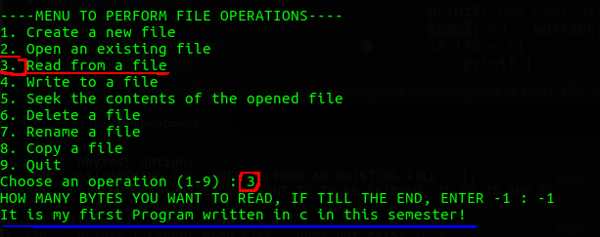

We choose the option 3 to read the opened file.

From the blue underlined text that changes were made to file and it has read the file where we wrote.

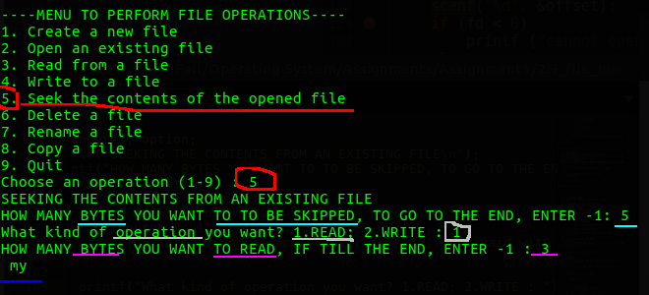

Now we will try to seek from a file and read it.

We choose the option 5 to seek from the opened file.

We choose how many bytes should be skipped inside the file. 5 bytes skipping is chosen.

We choose what operation we will do, 1st option to read the file.

We choose we want to read 3 bytes from the file.

We have been messaged with blue underlined text which represents reading file from 5 bytes till 8 bytes.

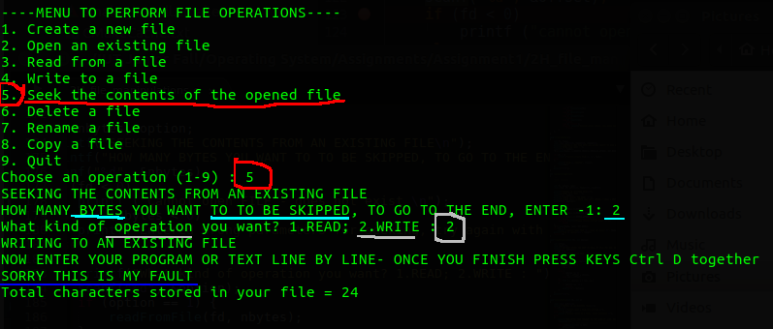

Now we will try to seek from a file and write into it.

We choose the option 5 to seek from the opened file.

We choose how many bytes should be skipped inside the file. 2 bytes skipping is chosen.

We choose what operation we will do, 2st option to write into the file.

We write the text we want, and to finish we press ^D.

We have been messaged in the last file that 24 bytes totals characters are stored into file.

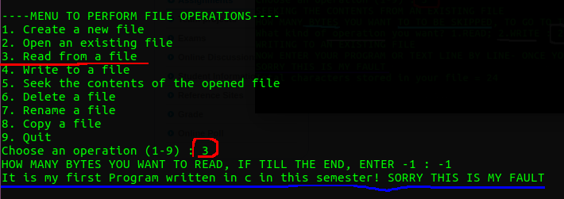

Now we will see the changes that we have made to file.

We choose the option 3 to read from the file

From last blue underlined text we can see what we wrote into file

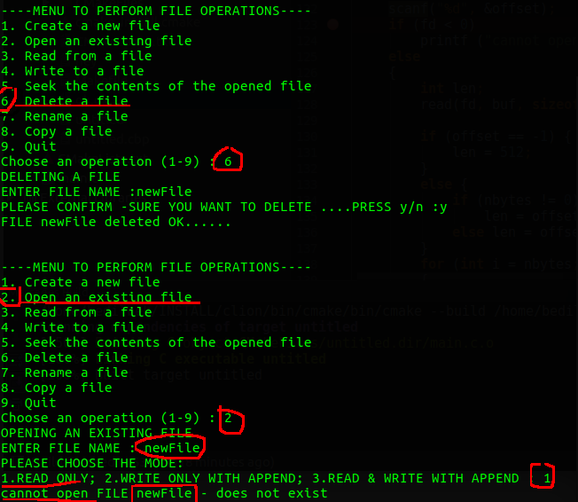

Now we delete file by choosing the option 6

we see the message that file is deleted

We check by opening the file with option 2

We see that file cannot be opened

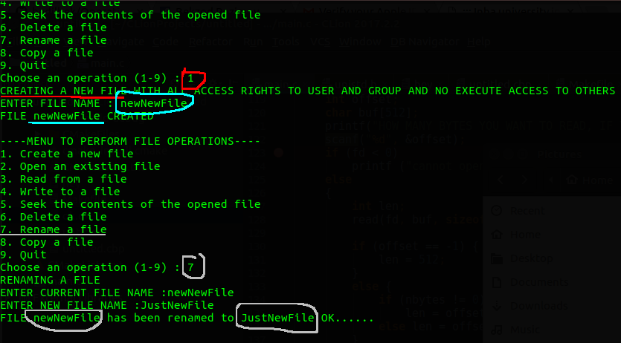

Now we rename the file.

First we will create file newNewFile by choosing the option 1.

Second, rename the file to JustNewFile by choosing the option 7.

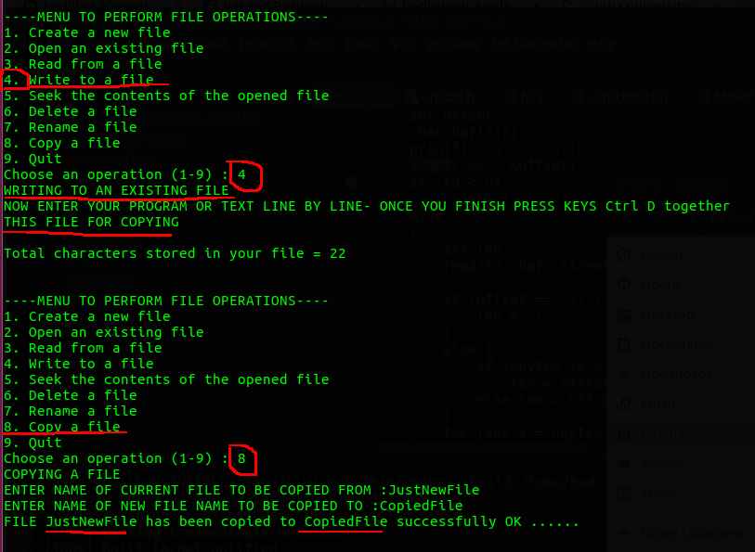

First we will write to a file text to copy it to other new file.

In the end we see that file has been copied to other file.

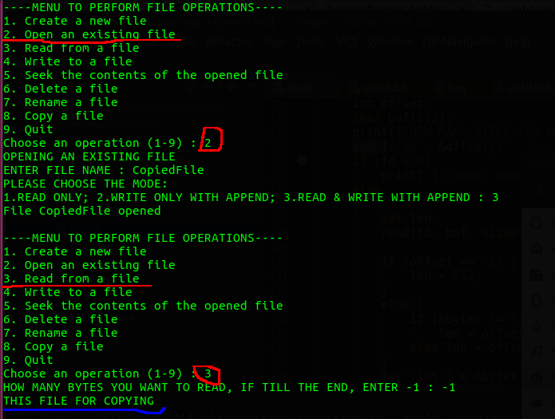

If we open and read the file, we see that file has been copied and all the text inside also has been copied to that file.

**###################################################################################**

**PART 3: Linux Kernel Source Code Installation**

**3A.**

All commands are executed in In Ubuntu Linux Distribution. In current time latest stable source version is 4.10.0. In this document we used “[version]” instead of “4.10.0”

To install linux source first we should update package list by executing command “sudo apt-get update”. It downloads the package lists from the repositories and "updates" them to get information on the newest versions of packages and their dependencies. It will do this for all repositories

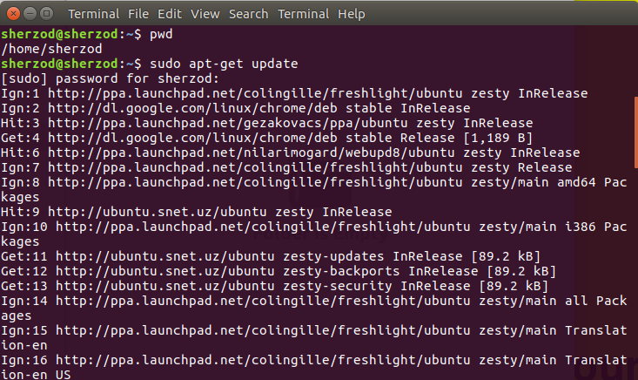

After updating we can start installing linux source. To do it, we execute “sudo apt-get install linux-source” it downloads tar archived latest stable linux source code from internet and stores to “usr/src/linux-source-[version]/”.

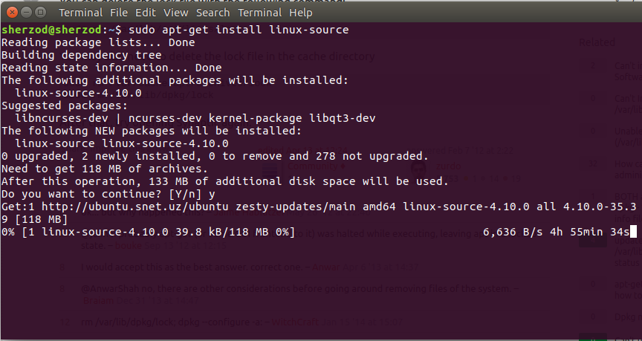

Because the source code is compressed we need to uncompress it using “tar xvjf usr/src/linux-source-[version]/ linux-source-[version].tar.bz2” command. The “tar” program is used to create, maintain, modify, and extract files that are archived in the tar format. The “xvjf” is argument for tar program, argument’s first letter is function, where:

x – to extract all files from archive

v – to operate in verbosely

j – this option tells tar to read or write archives using the bzip2 compressor

f – use archive file

The program extracts all linux source archive located in “usr/src/linux-source-[version]/ linux-source-[version].tar.bz2” to “home/user” directory

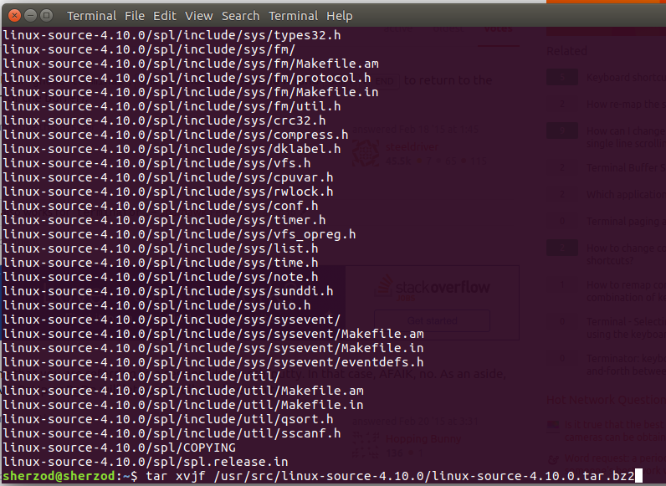

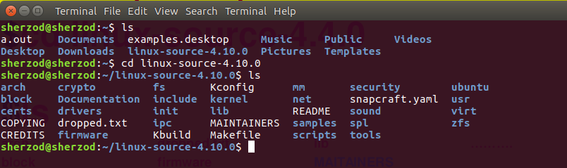

Linux source installation summary steps:

#updates packages list $sudo apt-get update

#downloads linux source archive $sudo apt-get install linux-source

#unarchive tar file $tar xvjf usr/src/linux-source-4.10.0/ linux-source-4.10.0.tar.bz2

**3B**

Here is the complete Linux kernel source directory tree in pdf:

[File: [3B/Linux Kernel Source Directory Tree.pdf](Linux%20Kernel%20Source%20Directory%20Tree.pdf)]

Here is complete linux source code files:

[File: [3B/Linux Kernel Source Files.docx](Linux%20Kernel%20Source%20Files.docx)]

Here are screenshots of commands:

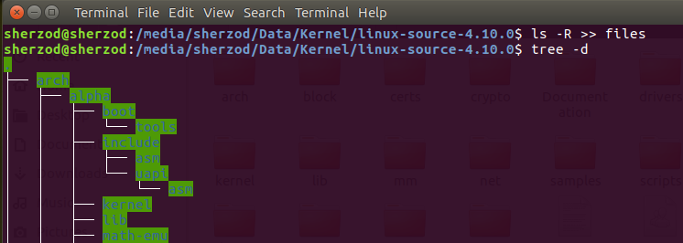

**###################################################################################**

**PART 4: Linux Kernel Source Code Compilation**

**4A**.

Compilation have done. Details are in 4b

**###################################################################################**

**4B.**

In order to compile installed linux source we need first install “libncurses5” and “libncurses5-dev”. “libncurses5” this package contains the shared libraries necessary to run programs compiled with ncurses. “libncurses5-dev” this package contains the header files, static libraries and symbolic links that developers using ncurses will need. To do this you need to execute “$sudo apt-get install libncurses5 libncurses5-dev”.

After we need to configure linux source, in which we can choose which features to include in our source. To do this “make menuconfig” is executed. It is a menu-driven user interface, allows the user to choose the features of Linux (and other options) that will be compiled. After configuring source we will save it. For simplicity here I left default options. Then packages list is updated by “$sudo apt-get update”.

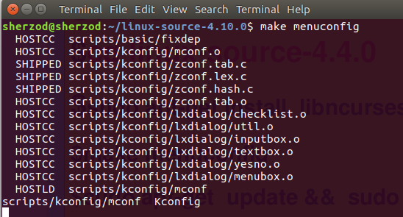

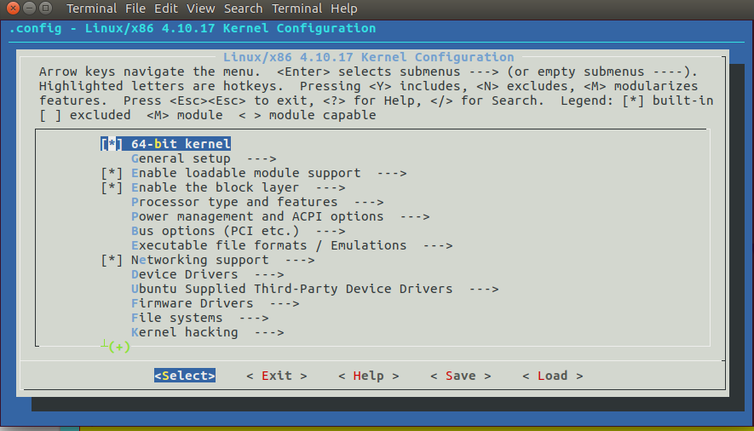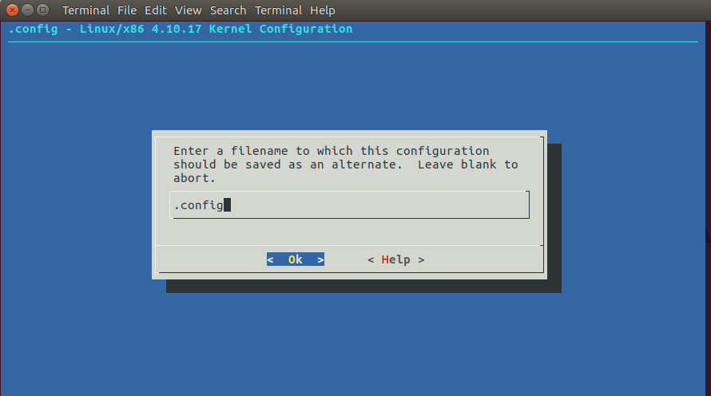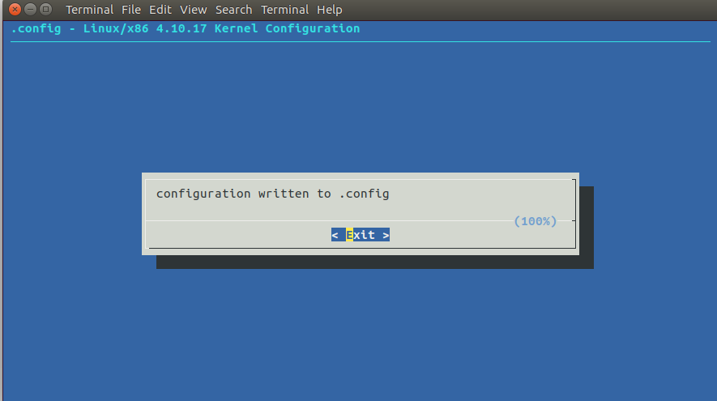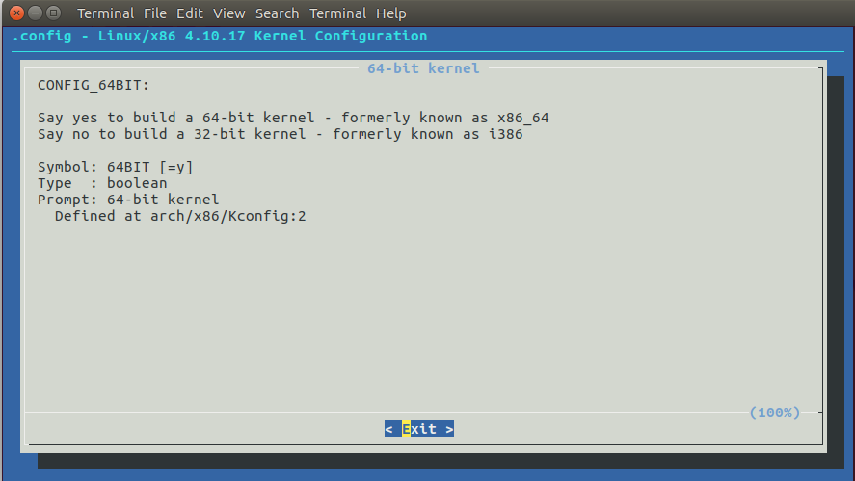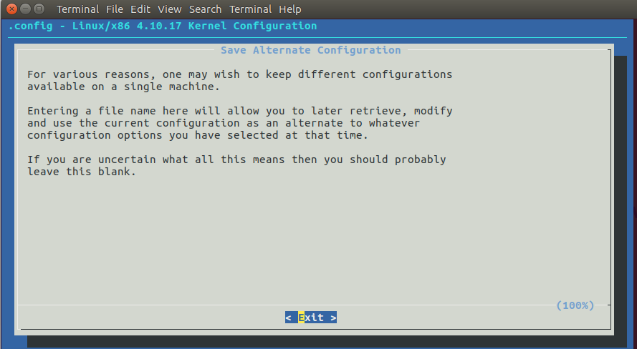

The next step is to install “libssl-dev” package which contains development libraries, header files, and manpages for libssl and libcrypto. This package is part of the OpenSSL project's implementation of the SSL and TLS cryptographic protocols for secure communication over the Internet. It is done by using “$sudo apt-get install libssl-dev”.

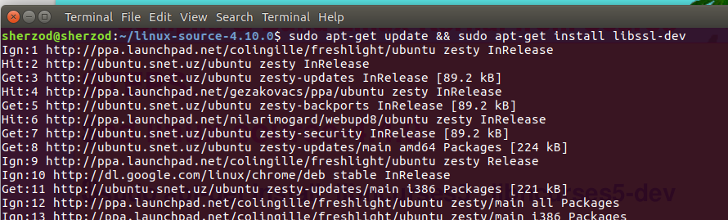

The final step before compilation is to execute “$make clean” comman. “$make clean” is something you do before recompiling, to make sure you get a clean build and don't have left-over by-products from previous runs.

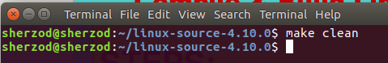

The final step is to compile and install kernel and modules using “$make deb-pkg”. The “make deb-pkg” command will create five deb packages in ../ that you will need to install with “$dpkg -i linux-*.deb”.

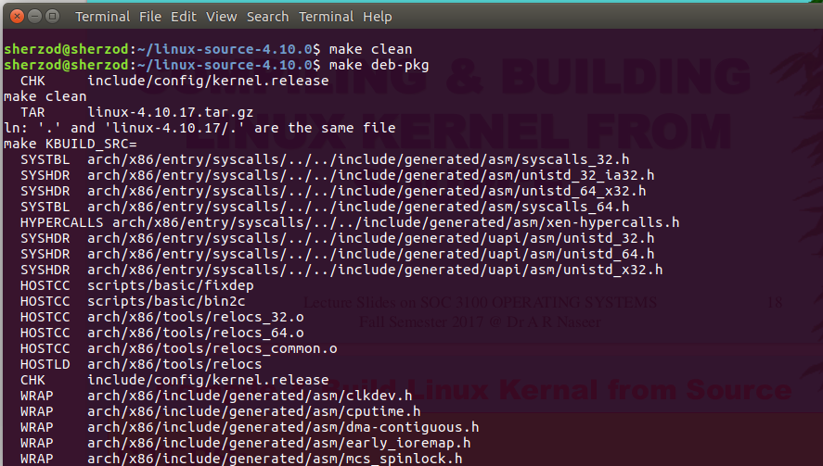

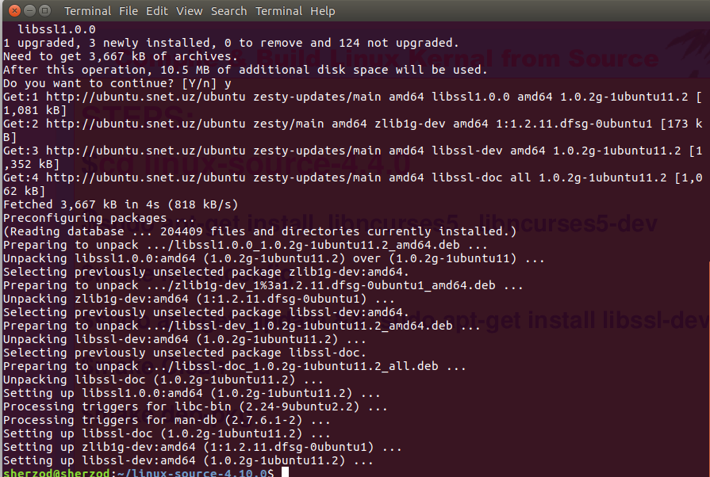

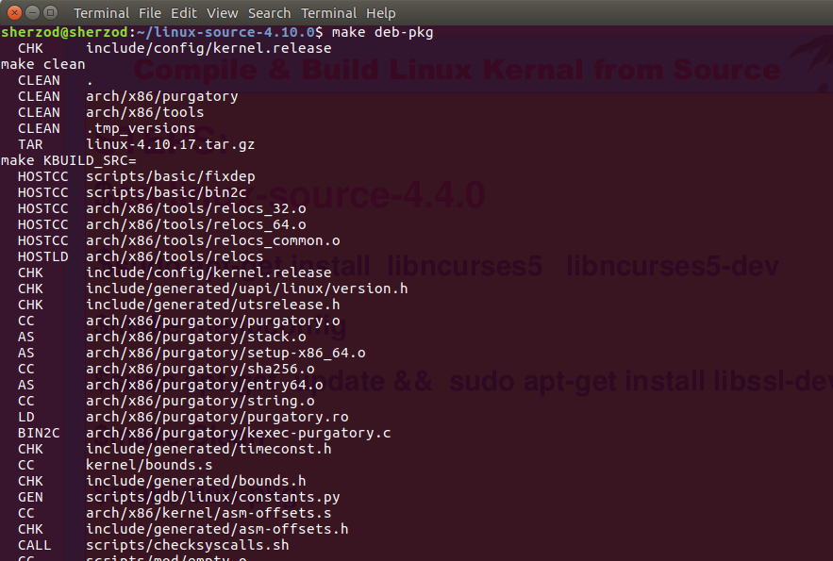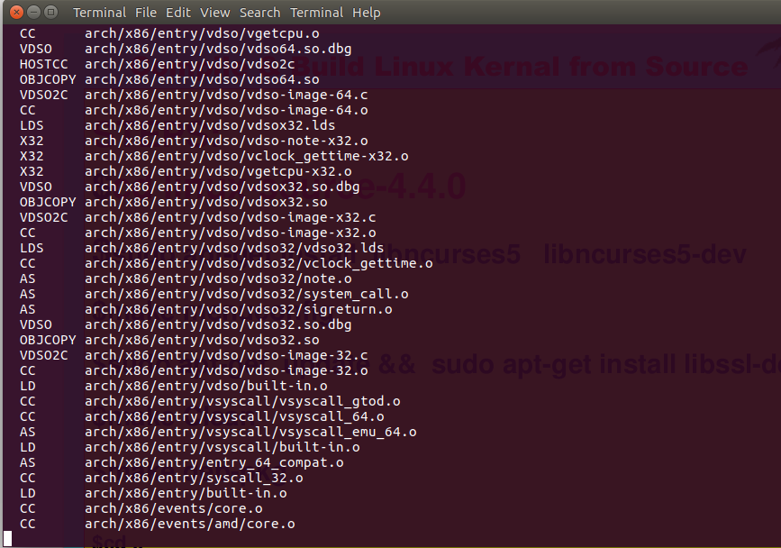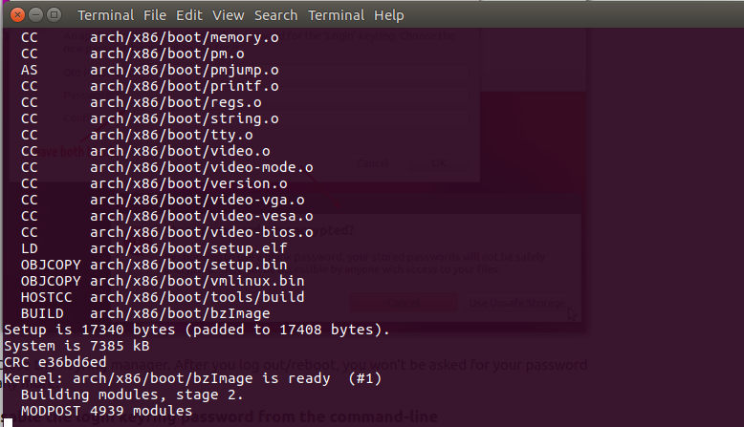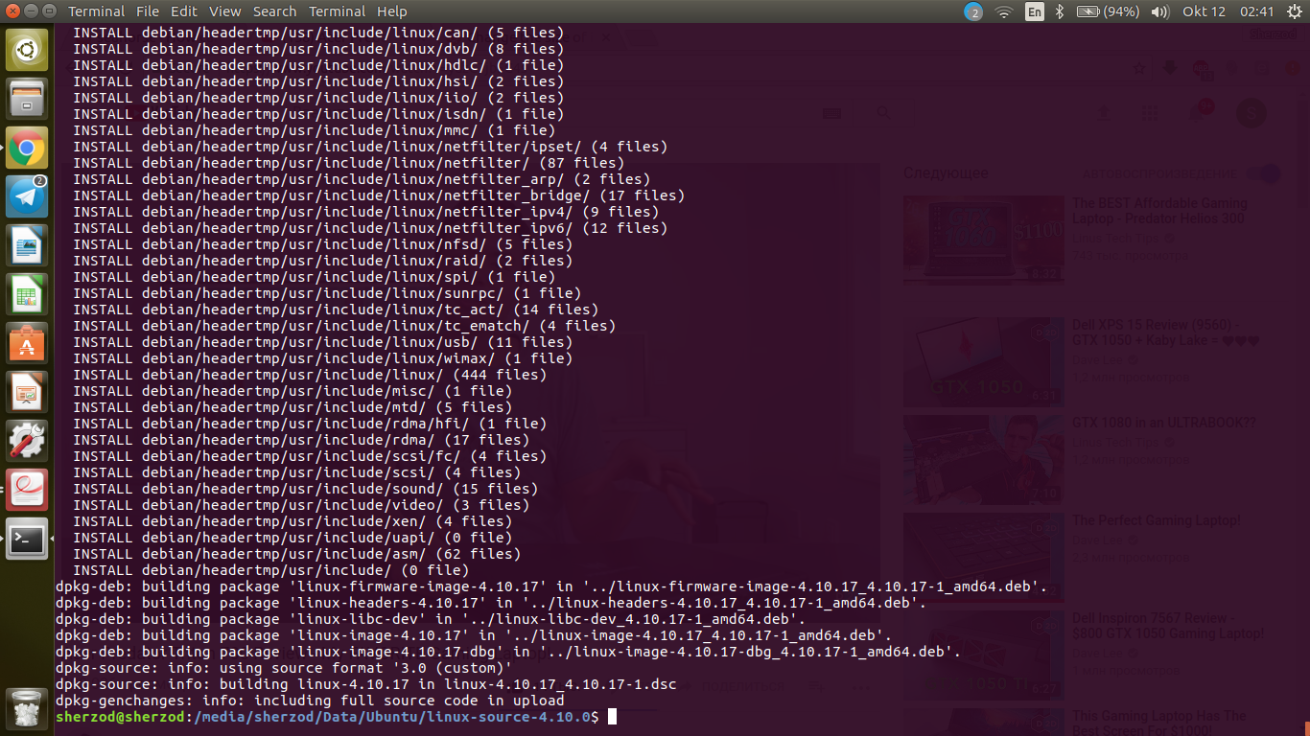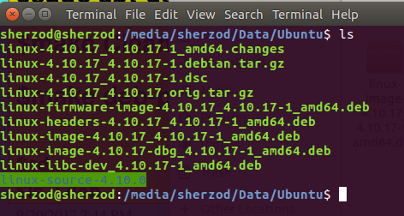

**###################################################################################**

**4C.**

To test you will install compiled “.deb” files from source with “$dpkg -i linux-*.deb”. After you can reboot to new kernel.

